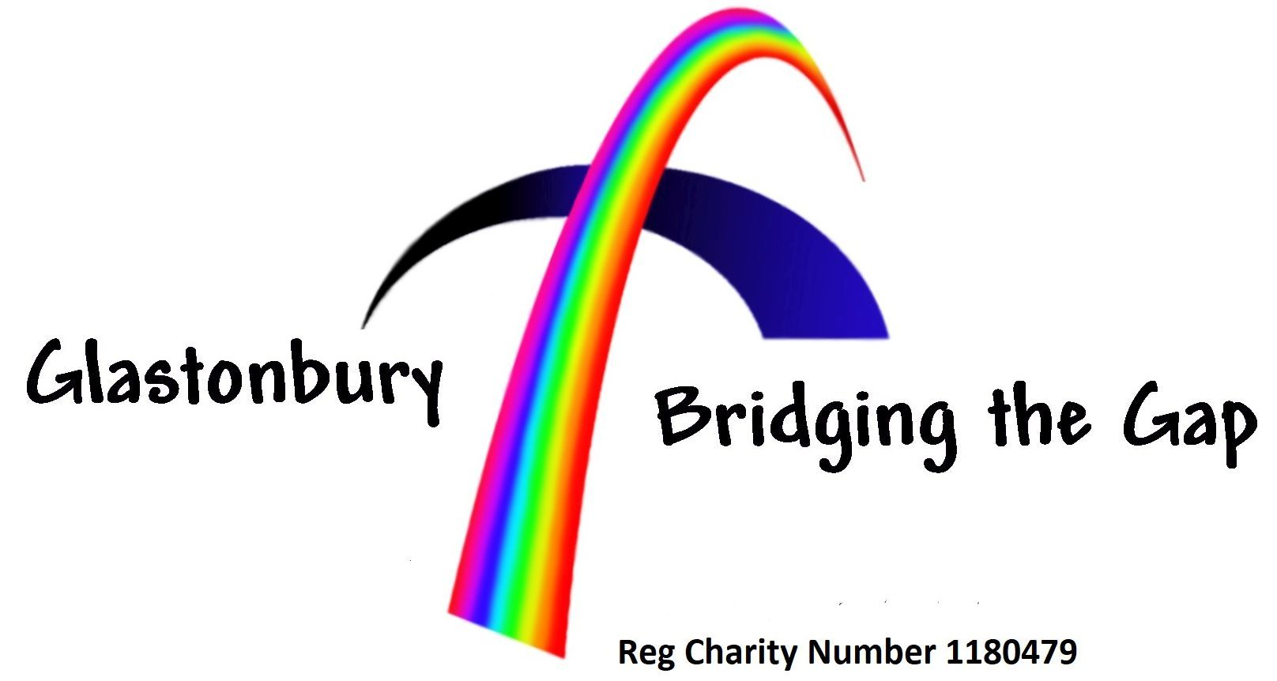

Can you help?

Bridging the Gap is a food bank and shelter pack scheme that supports individuals, couples, families and the homeless in Glastonbury, Street and the surrounding areas.

Stocks of non-perishable food and other essential items are currently running low, so if you would like to help there are a number of ways you can donate.

Drop-off points if you would like to donate items are:

- Morrison’s supermarket, Glastonbury
- Earthfare, Glastonbury High Street
- Nationwide Building Society, Glastonbury High Street
- United Reformed Church, Street
- Most Glastonbury churches

Otherwise you can volunteer or make a cash donation to help cover the cost of fresh food.

To find out more or if you would like to set up a local collection point for the scheme you can visit the Bridging the Gap website at https://together.ourchurchweb.org.uk/glastonbury/churches/foodbank/

Or contact them on 07980 458600.

Registered Charity No 1180479

