Mrs. L.A. Ruff, Clerk of the Council, Street Parish Rooms, 6 Leigh Road, Street, Somerset BA16 0HA Tel. (01458) 440588
Email street.parish@street-pc.gov.uk Website www.street-pc.gov.uk
22nd April 2021
PLEASE NOTE DATE AND TIME
Dear Sir/Madam,

You are summoned to attend the meeting of the Street Parish Council which will
be held virtually using Zoom with remote attendance on TUESDAY, 27TH APRIL 2021 for the purpose of transacting the business specified in the following agenda. Public Question Time will commence at approximately 6.55 p.m. The Chair will allow each person who has registered with the Clerk to speak for up to 3 minutes on any subject/s and will firstly explain the procedures for the meeting. Persons speaking will have been informed that the meeting will be recorded. The Council meeting will commence at approximately 7 p.m. or as soon as Public Question Time is closed by the Chair. Notes of Public Question Time on 16th March 2021 attached - Page 4. The meeting will be streamed live on YouTube on the Council’s YouTube channel at https://www.youtube.com/channel/UCiwCtXUydITXA9OpDqQfvIA/videos

In accordance with standing orders 7 c and d, a member with a disclosable pecuniary interest must leave the meeting and be placed in the waiting room during the relevant item of business, unless permitted to remain following the grant of a dispensation. Councillors
with an interest in relation to any item of business being transacted at a meeting under Appendix B (Other Interests) or where a matter relates to a financial interest of a friend, relative or close associate, may (i) make representations, (ii) answer questions and (iii) give evidence relating to the business being transacted but must thereafter leave the meeting and be placed in the waiting room, unless permitted to remain following the grant of a dispensation. At a convenient time the Chair will also give this opportunity to any members of the public who have registered to speak with the Clerk prior to the meeting.

Yours faithfully,
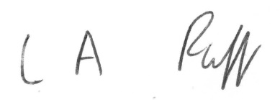

L.A. Ruff
Clerk of the Council
AGENDA

1. APOLOGIES FOR ABSENCE - acceptance of any reasons offered.

2. MINUTES
To approve as a correct record the minutes of the meeting of the Council held on 16th March 2021 (attached) Pages 5 – 12

3. MATTERS ARISING

4. DECLARATIONS OF INTEREST AND DISPENSATIONS
To receive declarations of interest from Councillors on agenda items and to
receive written requests for dispensations for disclosable pecuniary interests
(if any). Clerk to grant any requests for dispensation as appropriate.
- 1 -
5. COMMUNITY POLICE OFFICER

6. PLANNING COMMITTEE
To receive minutes of the meeting held on 16th March (attached) Pages 13 – 14
A response is required on no. 2021/0784/TEL prior approval of Telecommunications development for a street pole with built in cabinet and 3 separate cabinets on land at High Street (report attached) Page 14A
The application at Oaklands Nursery no. 2021/0249/FUL is to be refused by Mendip
under delegated powers. Ward members can refer this to the Planning Board.

7. CO-OPTION TO NORTH WARD (report attached) Pages 15 - 16

8. INTERNAL AUDIT AND SIGNIFICANT EVENTS (attached) Page 17

9. UNITARY WORKING GROUP
To receive notes of 30th March (attached) Pages 18 - 19

10. BUSINESS ACTION GROUP
To receive a verbal report

11. PARKING RESTRICTIONS
Report from ACPO on final recommendations (attached) Pages 20 - 23

12. MEETINGS (attached) Pages 23A – 23C

13. REPORT FROM CHAIR

14. PARISH PATH LIAISON OFFICER – County Cllr. Leyshon to give a verbal
report on behalf of PPLO Jake Dalton.

15. MENDIP STRATEGIC TOURISM FORUM verbal report of 8th April meeting

16. CHAIR UPDATES FROM OTHER COMMITTEES/WORKING GROUPS

17. CORRESPONDENCE/MINOR MATTERS (attached) Page 24

18. REPORT FROM REPRESENTATIVES ON OUTSIDE BODIES
AND COUNTY AND DISTRICT COUNCILLORS
Questions to be noted for written replies and matters for consideration
referred to the appropriate working group. All reports received have been
emailed to members.

19. ACCOUNTS FOR PAYMENT (schedule of payments attached for approval and
initialing by Chair to be arranged) and confidential detailed income and expenditure
by account report at 31st March 2021 including budget variance –
emailed to members only with bank reconciliations and earmarked reserves
schedule. Page 25 + Confidential attachment for members only

- 2 -

20. MATTERS FOR REPORT
Consideration of items not on agenda for information only
(a) Report from Clerk
(b) Matters raised by members - TO BE NOTIFIED TO THE CLERK IN
ADVANCE OF MEETING.

21. EXCLUSION OF PRESS AND PUBLIC
In accordance with the Public Bodies (Admission to Meetings) Act 1960 amended
by the Openness of Local Government Bodies Regulations 2014, it is probable that
a resolution will be passed at the meeting to exclude the press and public for item
nos. 22 to 25 below as they involve confidential information on staffing matters,
negotiations with the Pool Trust, a quote for digital boards and CCTV.

22. STAFFING COMMITTEE
To consider the minutes of the Committee meeting held on 31st March 2021
(attached for members only) Pages 26 - 27

23. GREENBANK POOL – GRANT
To discuss payment of the grant of £32,000 and the agreed close working
relationship with the Council.

24. DIGITAL BOARDS
To consider a Confidential report from the Clerk and ACPO on one quotation for a
Proposal (attached for members only) Pages 28 - 30

25. CCTV
To consider a Confidential update in regard to provision and monitoring of CCTV
surveillance (attached for members only) Pages 31 - 32

___________________

To: Chair and Members of Street Parish Council

- 3 -

NOTES OF PUBLIC QUESTION TIME HELD BEFORE
COUNCIL MEETING ON 16TH MARCH 2021

On behalf of a local resident the Clerk read out a request for Greenbank Pool to now open in the Summer as restrictions were lifted and the Council had given a grant of £32,000. The Pool Trust had confirmed that as discussed previously it would not be possible to open this year as the necessary preparations had not been made.

Another resident asked for confirmation that the war memorial would be moved within Merriman Park as this had been planned for a number of years. The Chair confirmed that it would be moved either now or at a later date as agreed by the Council.

- 4 -

STREET PARISH COUNCIL

Meeting of the Council held virtually using Zoom with remote
attendance on 16th March, 2021 at 7.04 p.m.

PRESENT: Councillor A. Leafe (Chair of Council)
Councillors: P. Birch, S. Carswell, M. Daniells, D. Drew, D. Goater, D. Knibbs, L. Mogg, T.W.E. Napper, A. Prior, H. Shearer, N. Smith and L. Wolfers

IN ATTENDANCE: L. Ruff – Clerk/RFO
M. Sandiford – Assistant Clerk Projects Officer
PC M. Pople – Street Beat Team
County Councillor Leyshon
V. Appleby, D. Atkins, K. Carr – Merriman Park
Community Group

APOLOGIES: Councillor R. Boyce – working – reason
accepted

181. MINUTES

The minutes of the extraordinary meeting held on 2nd March, 2021 which had been circulated were approved as a correct record and arrangements would be made for them to be signed by the Chair in accordance with current guidance.

182. MATTERS ARISING

Councillor Napper reported that he had raised the fact that 2 horses
were tethered on the grass in the middle of the bypass with County
Highways and asked PC Pople to investigate as well. Councillor
Shearer stated that she would also raise this with the District Council.

183. DECLARATIONS OF INTEREST AND DISPENSATIONS

In accordance with the Code of Conduct Councillors Carswell, Napper and Shearer declared an other interest under Appendix B in any matters relating to the District Council and stated that they would keep an open mind when considering issues at either District or Parish level. Councillor Napper also declared an interest under Appendix B in any matters relating to the County Council and that he would keep an open mind.

Councillor Drew declared an other interest under Appendix B in the Library as she was a Friend of the Library and a representative on the
Community Library Partnership and Councillor Prior was a volunteer.
They did not leave the meeting as no significant decisions were made.

- 5 -
Councillors Carswell, Daniells and Mogg declared an other interest under Appendix B in moving the war memorial within Merriman Park and left the meeting from 7.44 p.m. to 8.15 p.m.

Councillor Leafe declared a disclosable pecuniary interest in the grants
for the Glastonbury and Street CLP as his job was involved with this
and left the meeting from 9.40 p.m. to 9.45 p.m. Councillor Prior took
the Chair for this item.

184. MERRIMAN PARK

Representatives of the Merriman Park Community Group together with
park designer, Kate Carr gave a presentation on the past history,
overall design for the Park, works carried out and planned for the future
and funding applied for and received. The Group organised the annual
Fun Day with the Council and raised funds through raffles etc.

The Clerk reported that the mound by the toddler equipment in the new
play area was very popular and had become quite worn with muddy
areas and exposed stones which could cause injury. The area needed
to be made safe as soon as possible. The ACPO reported on the
suggestion from the Highways Group that the remaining Section 106
funding be used to provide bike racks in the Park.

RESOLVED

A. that the war memorial be moved to the new location as soon as
possible, subject to a contribution of £5,000 towards the cost from the
Community Group with the Council allocating £5,000 towards the cost
of providing the sensory garden and/or fitness area – the Community
Group would need to agree this decision

B. that Kompan be requested to rectify the mound in the new play
area and make it safe as rubble was used to form it and there are
exposed stones

C. that if Kompan did not agree to carry out the work needed on the
mound quickly, SLH Services be engaged to do this for £1,694.20 +
VAT

D. that the remaining Section 106 funding be used to provide bike
racks in the Park.

- 6 -
185. COMMUNITY POLICE OFFICER

PC Pople reported on the issues raised at the recent Meet the Team
meeting and that there would be a report back to the next one on
22nd April. The Clerk reported that a resident of Houndwood Close had
complained about an increase in anti social behaviour in the area with
noise, damage, intimidation and speeding. It was noted that any such
issues including cold calling should be reported by phoning 101 or 999.

County Councillor Napper reported that a dip in the road discussed had
been reported in 2020 and should be rectified by Highways.

The ACPO reported that the County Council would be making a
Traffic Order in due course and various restrictions etc. were being
considered for inclusion including in Ivythorn Road and Overleigh. He
asked PC Pople to email in the next 2 weeks with any suggestions and
to ask the traffic wardens to do the same.

RESOLVED

that the report be noted and information be included on the website on
how to report scams to Action Fraud and to report incidents of anti
social behaviour or cold calling to the Police by phoning 101 or 999.

186. PLANNING COMMITTEE

The minutes of the Committee meeting on 16th February were submitted as circulated.

RESOLVED

that the report be noted.

187. PROJECTS WORKING GROUP

The notes of the meeting on 18th February were submitted as
circulated. The ACPO reported that the bid to the Climate Change
Emergency Fund had not been successful and he would report on this
matter at the next meeting. County Councillor Leyshon thanked him for
the work done on this application.

RESOLVED

that the report be agreed.

- 7 -
188. HIGHWAYS WORKING GROUP

The ACPO submitted a report of the meeting on 25th February and
proposed parking restrictions which had been circulated.

RESOLVED

that the report be agreed and delegated authority be given to the
ACPO in consultation with County Councillors Leyshon and Napper to
agree the final recommendations to be put forward to the County
Council by the end of March on parking restrictions, repainting faded
markings, new no HGV signs and locations for new speed indicator
device poles.

189. STREET COMMUNITY LIBRARY PARTNERSHIP

The Clerk reported that the Library had re-opened on 8th March with a
limited service and the ACPO that the new signs would go up in a few
days.

RESOLVED

that the reports be agreed and approval given to the re-opening of the
Library from 1st March for 4 hour periods detailed by the Library Service
with no need at present for volunteers subject to Covid rates.

190. BUSINESS ACTION GROUP

Councillor Prior reported that the Group was considering lots of ideas
and that the ACPO was involved with many actions. It was agreed that
all members be invited to a presentation on digital boards the next day
and that this be recorded and sent to members. 3 companies had
been asked to submit details and the one chosen could consult with
Landsec, Millfield and others and seek funding. Glastonbury, Langport,
Somerton and Taunton all had or were going to have digital boards.
The ACPO had contacted the County Council and in principle such
boards could be installed provided they were not a distraction for
motorists. A licence would be needed from Road Records and a
Section 171 licence to carry out works on the highway. He also stated
that the item on broadband provision was on the website.

- 8 -
Councillor Wolfers had met with P. Eavis and it seemed probable that
the Chamber of Commerce would start again and be requesting a
grant. District Councillor Leyshon would report back when details were
available on levelling up and economic regeneration funding. The
ACPO reported that the Crispin Hall Manager was involved in setting
up the #Street Soul Trader campaign which would be similar to Shop
Local Glastonbury. Councillor Drew would send a link to a new idea to
use empty shop spaces to grow food. Councillor Prior reported that the
Greenbank Pool Group was looking at ideas such as merchandising,
a café, events in the grounds possibly this year and the new online
ticketing system. A substantial rates refund had been received.

The ACPO and Assistant Clerk were producing 4 or 5 colour maps of
walks in the Street area which would be available from the Library
which would also be the visitor centre and on the website. They were
also working with a local resident on maps for walks around the
boundaries of Street and on updating the Heritage Trail leaflet.

RESOLVED

that Councillor Mogg be appointed to the Group and the ACPO in
consultation with the Group be given delegated power to give a grant
of up to £250 for printing costs etc. associated with Street Soul
Trader.

191. CHAIR’S REPORT

Councillor Leafe had no report.

192. PARISH PATH LIAISON OFFICER

County Councillor Leyshon would find out if the PPLO would be able to
carry out maintenance work on paths. Councillor Prior reported a lot of
litter around the area.

RESOLVED

that Councillor Daniells be asked to contact the Somerset Probation
Service to see if they could clear litter and weeds in areas such as
Cemetery Lane, Sainsburys car park and on the boundary with
Glastonbury for a charge of around £10 a day.

193. MENDIP STRATEGIC TOURISM FORUM

The ACPO had given a good summary of current initiatives at the
last meeting.

RESOLVED

- 9 -
that the Mendip Tourism Strategy as circulated be approved.

194. STRATEGY AND SURVEY

The Clerk submitted the report which had been circulated.

RESOLVED

A. that the consultation and Summer survey be agreed with 5 prizes
of £100 for the best suggestion from a young person etc. to encourage
people to take part

B. that a meeting of the Unitary Group be held at 7 p.m. on 30th
March to consider the response to the Secretary of State on the 2
unitary proposals.

195. CHAIR UPDATES

No reports were made.

196. CORRESPONDENCE/MINOR MATTERS

The Clerk submitted a report which had been circulated. A resident
had raised concerns regarding parking of a large vehicle and speeding
in Portway. A bye election had not been called for the casual vacancy
on the North Ward and the notice would go up inviting candidates for
co-option.

RESOLVED

A. that the following appointments be agreed -

Appeal Panel – Daniells, Napper – 1 more needed
Grievance and Disciplinary Panel – Birch, Drew, Mogg
Street Community Library Partnership – Daniells
Victoria Club CIO – Birch
Mendip CCTV Users Group – Deputy – Leafe

B. that the Emergency Plan be sent to all councillors

C. that the ACPO and the Highways Group consider the issue of a
large vehicle being parked in an area on the junction of Housman Road
and Portway

D. that requests be made for overgrown hedges in Portway to be cut
back

- 10 -
E. that consideration be given to introducing traffic calming in Portway as part of the development of land off Somerton Road with the
District Council

F. that a grant of £2,000 be made to the Glastonbury and Street
Community Learning Partnership for support as detailed during the
Easter holidays and then a grant of £3,000 for support and resources
over June to August from the allocation for Issues for Street – vulnerable people etc.

G. that the sum earmarked in reserves for new bike racks be altered
to £3,753

H. that the report on investments with CCLA be noted and no change
be made to the Annual Investment Strategy 2021/22.

197. REPORT FROM COUNTY AND DISTRICT COUNCILLORS
AND REPRESENTATIVES ON OUTSIDE BODIES

County Councillor Leyshon reported that ground condition reports for
Cranhill Road car park were commercially sensitive and belonged to
Aster. Nothing was happening with the 2 proposed sites for social
housing while every possibility was being explored regarding the
alternative land offer including access and the need to bury 2 power
lines. Phosphates were also an issue.

198. ACCOUNTS FOR PAYMENT

The latest bank reconciliations for all accounts at 28th February, 2021
had been prepared successfully and sent to all members with the
monthly income and expenditure by account report, the final report of
receipts and payments for February, schedule of earmarked reserves
and a consolidated summary.

RESOLVED

that the report and schedule of payments as circulated be approved
and initialled by the Chair and the income and expenditure by account
report at 28th February, 2021 be noted and the schedule of receipts
and payments for March be attached as Annex A to the minutes in
the Minute Book in order to publish payments of £500 or more.

- 11 -
199. MATTERS FOR REPORT

The Clerk reported that SLH Services did not consider the problem of
dog fouling in Merriman Park to be that bad. She was investigating CCTV
provision with the other councils, Police and District Council and this was one
long term solution for women’s safety following the recent kidnap and murder
of a young woman in another part of the Country.

Councillor Smith asked if the Council could create income in some way
and the Clerk undertook to investigate the possible options. It was
agreed to monitor comments on the Council’s Youtube channel for any
spam links etc. so that these could be removed promptly.

The meeting ended at 10 p.m.

Councillor Daniells arrived at 7.12 p.m.
Councillor Wolfers left at 8.30 p.m.
Councillor Shearer left at 8.58 p.m.
Councillor Drew left at 9.48 p.m.

- 12 -

STREET PARISH COUNCIL

Meeting of the Planning Committee held virtually using Zoom with remote attendance on 16th March 2021 at 6:00 pm

PRESENT: Councillor L Wolfers - Chair
Councillor L Mogg – Vice Chair
Councillors P Birch, D Knibbs, N Smith

APOLOGIES : Councillors A Leaf

IN ATTENDANCE: J Marshfield – Assistant Clerk.
Mark Fitzgerald - Canynge Bicknell
33
24. MINUTES

The minutes of the meeting held on 16th February which had been
circulated, were approved as a correct record and signed by the Chair.

25. DECLARATIONS OF INTEREST AND DISPENSATIONS

None.

26. PLANNING APPLICATIONS

The Assistant Clerk submitted a report which had been circulated.

RESOLVED

2021/0213/FUL Proposal: Erection of 2no dwelling houses (2 bed and 3 bed semi) following the demolition of garages. Location: Land At 347398 136826 Houndwood Drove Street – REFUSAL Due to overshadowing surrounding properties, overlooking and loss of privacy from 1st floor windows. Access and egress issues as area used as public thoroughfare. Over development for size of plot.

2021/0261/HSE Erection of single storey extension to rear Location: 11 Moccasin Way Street - APPROVAL

2021/0379/REM Application for approval of reserved matters following outline approval 2014/2561/OTS and 2018/0339/VRC for the Development of Class B1 (business), B2 (industrial), B8 (storage/distribution) and A1 (retail) uses including an element of trade counter and builder's merchants uses and associated access. Matters of appearance/landscaping/layout/scale to be determined at Phase 6B Street Business Park Gravenchon Way Street – APPROVAL.

- 13 -
2021/0362/HSE Erection of first floor extension and a garage attic conversion at 4 Housman Road Street - APPROVAL

2021/0382/FUL Erection of single storey front extension to 2no. properties at 67 Grange Avenue Street - APPROVAL
2021/0437/HSE Loft Conversion at 14 Cranhill Road Street - APPROVAL

NOTE – 2 new units approved – 1 since July 2020.

The meeting ended at 6:40 pm.

- 14 -

To: Council
From: Asst. Clerk

Re: MDP16533 – Proposed new 5G telecoms installation located on High Street, Street

MDC powers are limited, they have no policy or power to halt 5G. 5G is market led and MDC must go along with what the Government advise.
Dot Surveying Ltd have issued a Pre-Application Proposal on 26th March to MDC and as long as they abide by legislation, this type of application doesn’t have to go through the normal planning channels. Although the General Permitted Development Order does not require a parish consultation the council has been consulted and any response will be taken into consideration when MDC makes a determination.

The Parish Council can potentially object by saying it will be intrusive, overbearing etc and possibly go along with other councils and adopt the precautionary principle and oppose the roll out 5G
https://stop5g.co.uk/councils-invoking-precautionary-principle/
However, objecting on health issues relating to 5G will not be considered as the Government are stating there are no health issues relating to 5G.

Frome TC decision from July 2019 below is a good summary
https://www.frometowncouncil.gov.uk/wp-content/uploads/2019/07/Agenda-Item-4-For-Decision-FTC-Position-on-5G.pdf

Wells City Council PLANNING ON 5G POLICY 7.11.19
Members discussed concerns raised at recent meetings regarding a future 5G
network in Wells. It was agreed to recommend to Full Council a Precautionary
Principle statement be adopted.

What is a Precautionary Principle in environmental law?
The precautionary principle requires that, if there is a strong suspicion that a certain activity may have environmentally harmful consequences, it is better to control that activity now rather than to wait for incontrovertible scientific evidence.
The principle implies there is a social responsibility to protect the public from exposure to harm when scientific investigation has found a plausible risk.

- 14A -

AGENDA ITEM NO: 8

To: Council
From: Clerk
Subject: Casual Vacancy on North Ward

The Chair to call for nominations to fill the vacant seat in the North Ward by co-option to the Council (procedure attached). As the period of the vacancy has more than 6 months to run the Council must co opt to fill it. P. Goater resigned from the Council in February 2021 and a poll was not claimed in time. Public notices have been displayed inviting suitably qualified people to apply to the Council for co option on the website and Facebook. The candidates who have stated that they wish to be considered for the vacant seat are as follows and their forms are attached for members -

None as at 27th April - if no one comes forward by the date of the meeting the
Item will be placed on the agenda for the next meeting.

All persons have certified in writing that they meet the criteria for eligibility set out in section 79 of the Local Government Act 1972 to be a member of the Council and are not disqualified pursuant to section 80 of the Act. To qualify as a candidate persons must live, have a business or work in Street or within 4.8 km for at least 1 year or be on the electoral role and be over 18 years of age.

Any candidate who is to be considered for co option until the end of the current term in May 2023 must be proposed and seconded at the meeting. Voting will be carried out in public by show of hands and candidates will be invited to go in to the waiting room for this.

The Council can then agree that the successful candidate is appointed to the committees and working groups which they indicated on the form that they wished to serve on.

L.A. Ruff
Clerk
27.04.21

- 15 -

A successful candidate must have received an absolute majority vote of those present and voting i.e. over half of the votes cast. If this is not the case voting continues until someone does have an absolute majority of votes cast. This is done by striking off the candidate with the least number of votes and the remainder must then be put to the vote again.

This will mostly be a satisfactory procedure but if several candidates have obtained the same number of least votes and the aggregate of the others is less than a normal quorum eg. 3:2:2:2:2, it may be thought wise not to strike off all those with the least votes together but, if negotiations for withdrawals fail, to strike them off one by one, in an order determined by vote.

If there is an equal number of votes the Chair can use their casting vote to decide on a candidate. The new co-opted member can if present, sign the declaration of acceptance of office and then take part in the meeting but as it will be a remote meeting and, if not present can sign before or at the next ordinary meeting of the Council.

- 16 -

AGENDA ITEM NO: 9

To: Council
From: Clerk
Subject: Internal Audit and Significant Events

The Council is asked to agree the attached terms of reference for the internal auditor, Probusiness Ltd. Tom Bacon of the company will carry on the internal audit of the accounts for the year ended 31st March, 2021 at the Parish Rooms on Thursday, 29th April with the Clerk in attendance. The ACPO will join us when his CiLCA training session ends.

The Council is asked to consider if any events that occurred during the financial year or after the year-end, have consequences, or potential consequences, on the Council’s finances. If any such events are identified eg. damage to or theft of a significant asset, the Council then needs to determine whether the financial consequences need to be reflected in the statement of accounts. The coronavirus emergency was discussed and delegations agreed to carry on the Council’s operations if necessary in 2020. An annual allocation of £55,000 for Issues for Street – vulnerable people etc. is being used to fund grants to recognised organisations assisting residents during the crisis. A separate record is being kept of expenditure related to the coronavirus emergency as this may be refunded by a larger authority at a later stage. Donations from local businesses and other organisations will also be sought. I therefore see no need to reflect this in the statement of accounts for 2020/21.

L.A. Ruff
Clerk/RFO
27.04.21

- 17 -

AGENDA ITEM NO: 10

NOTES OF UNITARY WORKING GROUP ON 30TH MARCH, 2021

PRESENT: Councillors Knibbs, Prior and Smith
L. Ruff – Parish Clerk/RFO

APOLOGIES: Councillors Carswell, Drew, Napper, Shearer

1. ELECTION OF CHAIR

AGREED

that the Chair be elected at the next meeting.

2. ELECTION OF VICE-CHAIR

AGREED

that Councillor Knibbs be elected as Vice-Chair of the Group.

3. RESPONSE ON 2 PROPOSALS FOR UNITARY IN SOMERSET

The Clerk submitted a report which had been circulated.

RECOMMENDATION

that the Council’s response to the Secretary of State on the unitary proposals for Somerset should be as set out below -

The unitary process will allow the way in which local government in Somerset operates to be reconsidered for the first time in 50 years. There are a number of major problems to be tackled over the next 15 years to 2035 including the ever increasing cost of child and adult health and social services due to an ageing population, troubled families and 25% or more of children in poverty. There will also be issues concerning climate change and the affects of the pandemic with a need to provide better paid jobs and more opportunities for the young. At the same time there will be less funding and resources and so it is felt that local councils will play a crucial role in assisting with the delivery of community support and other services. This has already been carried out over the past year very effectively by councils working in partnership with other local organisations.

If any new system of local government is to work well there will need to be a strong relationship between local councils and the new unitary as well as other public and private bodies. The One Somerset and Stronger Somerset proposals both include the establishment of Local Community Networks. These would hopefully meet regularly to make important decisions at a local level in consultation with various representatives from local councils and other organisations. There is concern that similar operations set up in the past involving Area Boards etc. did not work very effectively. The Minister is therefore urged to ensure that full and proper engagement with communities does take place when the new system is set up. This will ensure that local councils and others can assist in meeting the needs of local people. It is also very important that local councils are named consultees in all future consultations.

- 18 -

4. FUTURE ASPIRATIONS FOR STREET

The Clerk submitted a report and a Confidential report on CCTV surveillance which had been circulated. It was felt that outside activities should be encouraged as the spread of Covid 19 was much less likely and that places such as Merriman Park, the Victoria Club and Greenbank Pool could be used to hold community picnics, fitness classes etc. It was important for facilities such as the Pool to diversify and find ways to create income so that in future the Council could give support where it was most needed.

AGREED

1. that the Clerk should report on the rules relating to the Council creating income streams to inform on what was permitted as this would enable more assets/services to be taken on without a need to increase the precept

2. that provision of fast fibre broadband in Street was important for all and with many new houses planned it was also vital to ensure that the necessary infrastructure was in place including GP surgery and NHS dentists

3. that the Clerk should report on what had worked well for similar sized councils in areas which had already become unitary authorities and whether they had received funding when taking responsibility for assets or services

4. that the Mendip Markets Manager be invited to a future meeting of the Business Action Group to discuss plans and options to create more of a vibrant atmosphere in the High Street during the Thursday market – ideas to include having more tables and chairs outside, closing the High Street on a Saturday, having double sided stalls, incorporating this with the launch of the Chamber of Commerce and asking shops to have stalls and assist in funding the road closure

5. that when the staff were working in the office again consideration be given to employing an apprentice to assist with the workload

6. that the YMCA be informed that the graffiti art on the Skate Park needed to be repainted

7. that Councillors Knibbs and Smith would assist with hiring out the rooms in the Parish Rooms when this was considered safe, as this could create a substantial income for the Council and both had experience in this area

8. that Councillor Prior would contact SASP to find out if any funding was available if it could be proved that community health in Street was getting better.

The meeting ended at 8.15 p.m.

- 19 -

AGENDA ITEM NO: 12
Review of Parking Restrictions
Somerset County Council are looking at putting forward an Amendment Order for Mendip in the new financial year and have requested that Street Parish Council provide any requests for enforceable road markings / parking restrictions, that need to be subject to a Traffic Regulation Order.

At the council meeting of 16 March 2021, it was agreed that the ACPO, in conjunction with County Councillors Leyshon and Napper, be given power to agree the final recommendations. The following recommendations were forwarded to Somerset County Council on 26 March.

New TROs to be considered:
No. | Location | Comments
1 | Junction from Football Club onto Middle Brooks | Parking on junction obscures view when exiting onto Middle Brooks; particularly on match days.
2 | Junction of Willow Road / Goss Drive | Parking on junction obscures view
3 | Between Brooks Road (South of Junction to Goss Drive) and Middle Brooks | Continuous line of parked cars during term time causes issue with traffic flow, and obstruction for wider vehicles.
4 | Crossroads between Ivythorn Road/Middle Leigh/Oriel Road | Visibility left from Ivythorn Road extremely poor due to position of telegraph pole.  Parking on junction of Ivythorn (left side going up the road) is dangerous for cars turning into Ivythorn from Middle Leigh.  Parking on junction of Oriel Road obscures view
5 | Oriel Road, opposite to junction to Tanyard | Parking opposite junction causes obstruction when exiting Tanyard
6 | Junction of Silver Road / Leigh Road | Parking on junction obscures view
7 | Junction of Houseman Road and Portway | Parking on junction obscures view.  Consideration needs to be given to existing pull-in. Complaints received from residents regarding vehicles being left for long periods of time.
8 | Junction of Petvin Close and Portway | Parking on junction obscures view
9 | Start of Grange Avenue from A39 | Parking on junction obscures view
10 | Glaston Road, opposite church  - 20 - | Parking interferes with flow of traffic on main carriageway through village via B3151
11 | Orchard Road between High Street and Back Lane | Parking Enforcement Officers have highlighted issue with cars parking too near the junction (including blue badge holders). Reduces visibility and makes it difficult to turn into Orchard Road from the High Street
12 | High Street, outside of Burns the Bread | Cars are often parked outside of bakery or bank, making it difficult for bus to turn right from Leigh Road onto the High Street. Review existing parking restrictions
13 | Overleigh leading from Ivythorn Road, and Junction into Overleigh | Parking down this narrow stretch of road has caused concerns from the fire service
14 | Fowen Close | Parking has caused concerns from the fire service
15 | Corner of Road into Icon estate from A39 (towards Moonraker Square/Wessex Court) | Parking obscures view
16 | Entrance to Bullmead Parade | Parking obscures view

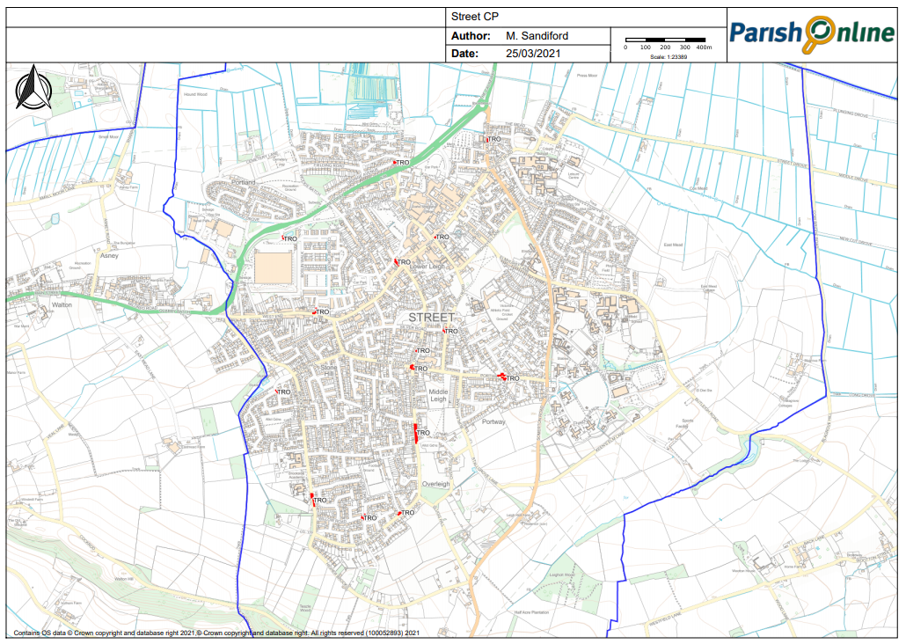
15
16
14
13
12
11
10
9
8
7
6
5
1
4
2
3

- 21 -

Repainting of existing road markings to be considered:
 | Location | Comments
17 | High Street, west of Goswell Road | Refresh of double yellow lines
18 | Junction from Overleigh to Ivythorn Road | Junction is no longer visible due to resurfacing
19 | Opposite Wessex, outside of McColls and along to chip shop. | Mel Reynolds, Parking Enforcement Base Manager for Mendip, reports problems as cars need to cross white line to pass, and there is a crossing point. Lines need repainting.
20 | Traffic calming in High Street, towards Mullions Hotel | Priority and mini cycle lane have become very faint

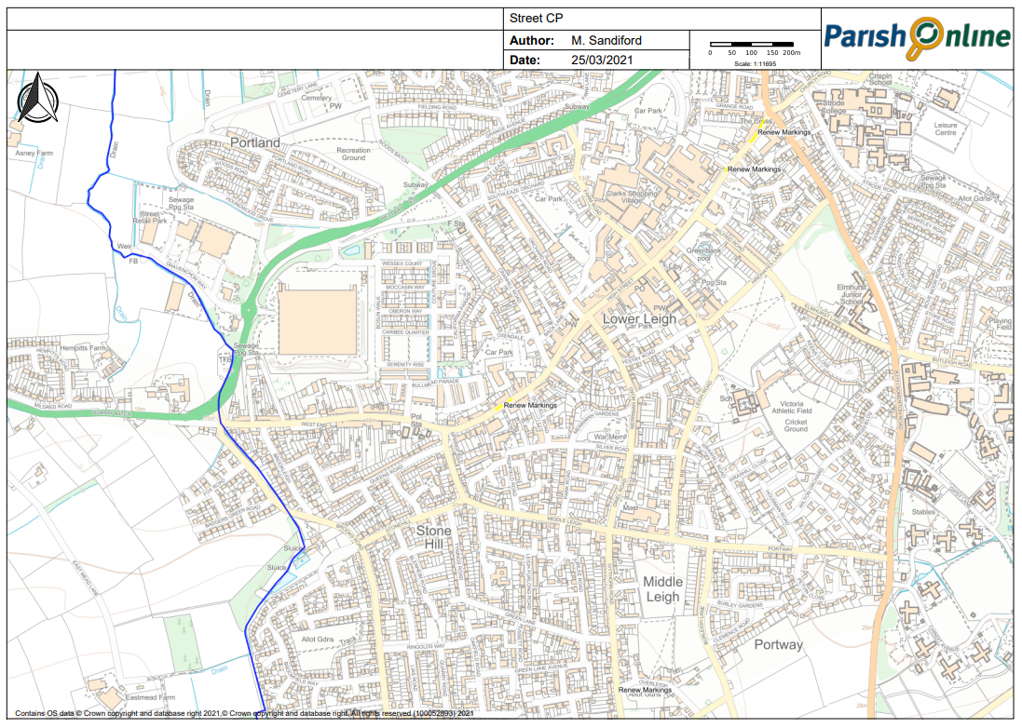
18
19
20
17

New road signs to be considered:
 | Location | Comments
21 | Entering Street at Slugg Hill | No HGV sign required (access for deliveries only)
22 | Traffic Lights Entering Street from A39 from Walton | No HGV sign required (access for deliveries only)

- 22 -
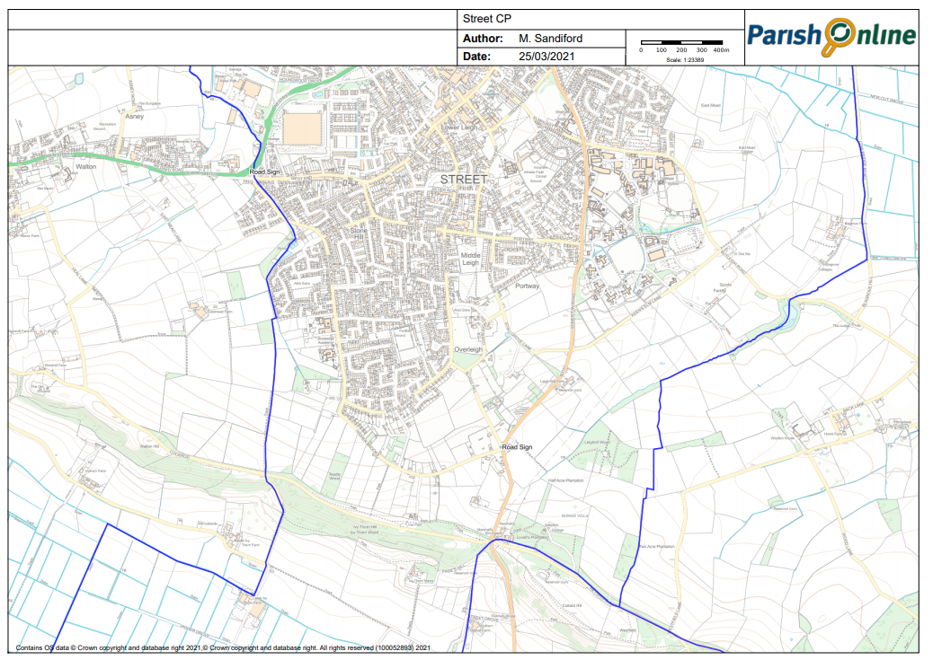
21
22
New locations for Speed Indicator Device (SID) poles to be considered:
 | Location | Comments
23 | Grange Avenue | Speeding vehicles
24 | The Mead | Speeding vehicles using route as cut through to college car park
25 | Portway | Speeding vehicles from Somerton Road
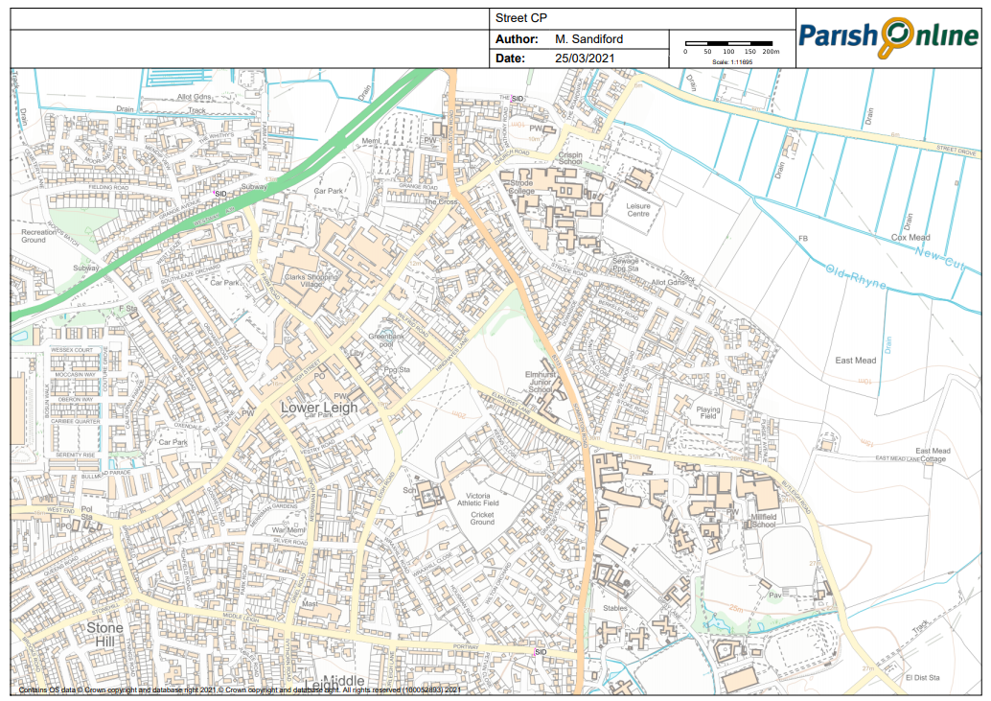
24
25
23

ACPO – 30/03/2021

AGENDA ITEM NO: 13

To: Council
From: Clerk
Subject: Meetings

The Government has announced that remote meeting powers will not be extended. NALC and LGA have expressed their disappointment. Guidance on the safe use of council buildings has been updated to help councils operate safely and securely, including using existing powers to reduce the number of face-to-face meetings deemed necessary. Several bodies have applied to the court for a declaration and this was expected to be determined before the end of April.

There is a risk assessment in place for the Parish Rooms following the latest guidance on Covid 19 but the meeting room on the first floor is quite small. The Assistant Clerk has investigated options for face to face meetings. The Crispin Hall is already booked. She has suggested that we move the book shelves back and use the main library room for physical meetings if and when this becomes necessary. The library is not open on a Tuesday so we could set up ready for the evening. At the end of the meeting the room could be sanitized by letting off an anti viral room fogger disinfectant. On 19th May 2020 it was agreed that if the Council was unable to meet for whatever reason, the Clerk be given delegated authority to progress matters and authorize payments in line with the budget. The full decision is set out at the end of this report and this power could be used as an option to minimize the number of meetings held. When considering this option members should have regard to the democratic implications to ensure that local residents are appropriately represented and that all local authority decisions have appropriate scrutiny. Some decisions including approval of the Annual Return and accounting documents cannot be delegated and require a decision by full council. Remote meetings can be held up to and including 6th May.

The Council is asked to agree that there is no Policy and Finance Committee meeting on 11th May to consider the end of year accounts, and that the annual meeting of the Council is held remotely on Tuesday, 4th May to elect the Chair, Vice-Chair, appoint committees, working groups and representatives on outside bodies and to consider and approve the Annual Return and other documents.

Alternatively the Government’s roadmap proposes that organized indoor meetings are permitted from 17th May subject to Covid secure guidelines and capacity rules. The annual meeting of the Council could be held as a physical meeting on 18th May following a remote Policy and Finance Committee on 4th May.

The Council has a legal obligation to ensure that members of the public can access most meetings and the Government is encouraging provision of remote access for the public until at least 21st June when it is anticipated that all restrictions on indoor gatherings will be lifted. It is for individual local authorities to satisfy themselves that they have met the requirements for public access. A number of other councils have not been streaming meetings live on Youtube and this may be difficult to set up for a physical meeting at such short notice.

In addition the Council must again hold the Annual Parish Meeting by 1st June and this cannot be a remote meeting. This will be considered at the annual meeting on 4th May when the latest guidance can be taken into account on the way forward.

The Council has a legal responsibility to protect officers, elected members and others from risk to their health and safety including from the risks of Covid 19. Those attending physical meetings must maintain social distancing wherever possible. Where a 2m distance is not viable mitigating actions would include:

- 23A -

- further increasing the frequency of hand washing and surface cleaning
- keeping the meeting time as short as possible
- using screens or barriers to separate people from each other
- using back-to-back or side-to-side working (rather than face-to-face) whenever possible.

Social distancing applies to all parts of the building including entrances and exits and break rooms. Other steps usually needed will be:
- meetings where in person attendance is not required should continue to be held virtually
- only absolutely necessary participants should physically attend meetings and should maintain social distancing – 2m or 1m with risk mitigation
- avoiding transmission during meetings eg. not sharing documents
- providing hand sanitizer
- using well ventilated rooms whenever possible
- for areas where regular meetings take place, floor signage to help maintain social distancing.

Toilets should be kept open and carefully managed to reduce the risk of transmission. Steps usually needed: signs and posters, social distance marking, limited entry approach, hand sanitizer, running water, paper towels, frequent cleaning, well ventilated, more waste facilities and more frequent waste collection.

In light of the coronavirus (Covid-19) pandemic and any other future emergency and government advice this council resolves that:
- Should the council be unable to meet for whatever reason, the
Clerk be given delegated authority to progress all ongoing matters and projects and authorise all regular payments and incur expenditure in line with the council’s agreed budget
- Any decisions taken under resolution (a) above will be taken,
whenever possible, in consultation with the Chair and Vice Chair of Council and the relevant committee chair (if appropriate). A record of all decisions and expenditure incurred under delegated authority will be kept and reported to members when the council next meets
- The authority to decide the council’s response to planning
applications be delegated to the Clerk or Assistant Clerk, in consultation with the Chair of the Planning Committee and Chair and Vice Chair of Council. Whenever possible, members of the Planning Committee (or Council in the case of large applications) will be informed of applications out for consultation and will be invited to submit comments to the Clerk or Assistant Clerk
- The provisions outlined in resolutions (a) to (c) above will override
any requirements to the contrary in the Council’s standing orders, financial regulations or terms of reference
- In the interest of staff, volunteer and public safety the Council
office will be closed to the public, except by appointment, whenever government advice deems this to be appropriate
- In line with government advice, staff will be encouraged to work
From home
- Should the Clerk be unable to perform her duties, the Assistant
Clerk or Chair or Vice Chair of Council or if they are unavailable, another councillor will assume the role of Proper Officer and RFO, in an unpaid capacity with the exception of the Assistant Clerk

- 23B -
- The Clerk, in consultation with the Chair and Vice Chair, may
incur expenditure from the project earmarked reserve where such expenditure will help the community’s efforts to support those in need of assistance or prevent social isolation
- Should government allow councils to meet virtually (online), the
Council will take all reasonable steps to facilitate this
- Funding to support the community should be made through
recognised organisations only such as the Foodbank, Salvation Army and Bridging the Gap and anyone asking for assistance should be referred to an appropriate organisation
C. An email to be sent to the Community Centre and other
organisations as appropriate making it clear that funds were available to them and that if they applied to the Council they would be supported very quickly
D. Positive community news to be posted once a week on the website, Facebook etc.

- 23C -

AGENDA ITEM NO: 18
To: Council
From: Clerk
Subject: Correspondence/Minor Issues

1. Appeal Panel

Following the resignation of P. Goater to agree 1 more councillor to serve on the Appeal Panel with Councillors Daniells and Napper. This cannot be Councillors Birch, Drew or Mogg as they serve on the Grievance and Disciplinary Panel.

2. Merriman Park Fun Day – Saturday 4th September

At the request of the Park Community Group to agree to fund the annual Fun Day with bookings from early June provided that it looks like such an event can go ahead and that we can have a refund if it is cancelled. The budget allocation for this event is £6,000.

3. New Grounds Maintenance Contract

To agree that the Clerk in consultation with the Chair and Vice-Chair can draw up a tender document for a new 3 year contract incorporating inspections and grounds maintenance at the Skate Park and Merriman Park, watering the baskets and all other works currently carried out by SLH Services. This would run from 1st November 2021 to 31st October 2024 and would give time for the new unitary authority to commence operating from Spring 2023 and to consider any additions or changes in the future eg. the Council becoming responsible for more play areas.

Tenders would then be invited on Contracts Finder website and the Council’s website for consideration by the Council.

4. New Insurance Agreement

To agree that the Clerk in consultation with the Chair and Vice-Chair can seek quotes for a new 3 year insurance agreement with mainly the same policy details as currently in place and agree which quote to accept from 8th June 2021. The cost is likely to be around £2,500 per annum.

L.A. Ruff
Parish Clerk
27.04.21

- 24 -

AGENDA ITEM NO: 20

To: Council
From: Clerk
Subject: Accounts for Payment

The latest bank reconciliations for all accounts at 31st March 2021 have been prepared successfully and sent to all members with the monthly income and expenditure by account report and earmarked reserves. Each reconciliation and original bank statement will be signed by Councillors Carswell and Prior as part of the monthly check of accounts when guidance allows and Councillors Daniells and Mogg are doing an online check.

Receipts and payments are detailed on the attached pages and a final report for April will be sent to members in early May.

L.A. Ruff
Clerk
27.04.21

Approved by Council on 27th April 2021 and initialled by Chair:

- 25 -

