6 LEIGH ROAD, STREET, BA16 0HA 01458 440588 street.parish@street-pc.gov.uk

Background

Street Parish Council is inviting contractors to tender for the grounds and horticultural maintenance contract for Merriman Park, the Street Skate Park, the Strode Road Allotments, the centre of the roundabout on the Westway near McDonalds and the Parish Council flower beds and hanging baskets on a performance basis, utilising the Mendip District Council Standards Management Pictorial Guide as a reference document (available upon request). Additional works – cleaning 4 bus shelters and maintenance/moving 3 speed indicator devices to locations around Street.

Street Parish Council wish to offer a contract to manage our grounds and horticultural maintenance requirements and carry out all works specified.

Tender

Street Parish Council is inviting tenders to undertake the duties detailed in Street. The successful contractor must be flexible when ad hoc work is required. This is to be paid for on a pro rata basis.

You are invited to bid on all parts of the contract or on any part as you prefer. Please state whether the contract price is for the work alone, or includes salary contributions.

Please note that Part 4 – Bins and litter and the additional works listed are entirely optional and tender returns will be considered with and without the duties listed.

The Parish Council is not obliged to accept the lowest or any tender. Prospective contractors are prohibited from contacting councillors or staff to encourage or support their tender outside of the prescribed process.

Tenders are invited on a sealed bid basis by 12 noon on Friday 20th August 2021, on which date they will be opened. Contracts will be announced shortly afterwards. Contracts will commence on Monday 1st November 2021 and end on 31st October 2024.

Tender Return

Sealed tender documents in a clearly marked envelope or email are to be returned to:

Parish Clerk
Street Parish Council,
Street Parish Rooms,
6 Leigh Road,
Street,
Somerset,
BA16 0HA
Email street.parish@street-pc.gov.uk

Part 1a - Merriman Park Horticultural Contract
Item | Detail | Price
- Grass Cutting | 7029 Sq. metres  Cut to Grade A – Grass Maintenance  Grade B acceptable only if wet and inoperable. | £
- Hedge & Shrub Maintenance | Approx. 400 Sq. metres of hedge  Required 4 times per year. Some of the hedge is by parked cars and a road. Access and highway/traffic visibility to be maintained and available year round.  Please note the restrictions between 1st March – 31st August:  https://www.gov.uk/guidance/countryside-hedgerows-regulation-and-management  Cut to Grade A  Grade B acceptable if wildlife is present or if horticultural restrictions are imposed.  Shrubs to be maintained at the same time as hedges.  Additional cuts may be authorised if there is a health and safety issue. | £
- Trees | Report any tree issues.  Note: The Parish Council will arrange for an independent annual inspection by a professional tree surgeon who will also carry out any work after each inspection. | £
- Leaf Removal | Sweeping and removal of leaves on a weekly basis throughout Autumn (1st September to 30th November).  Additional leaf removal may be required prior to any occasional event including the Fun Day on 1st Saturday in September.  Grounds Maintenance Amenity Planting standards to be followed.  Grade A expected.  Grade B acceptable if extreme weather is experienced. | £
 | TOTAL COST | £

Part 1b - Merriman Park Maintenance Contract
Item | Detail | Price
- Street Cleansing | Clean out the gulley in Spring and Autumn | £
- Public Seating | All seats to be cleaned throughout the year.  Asset Maintenance (Street Furniture) standards to be followed.  Grade A expected, Grade B acceptable (within reason). Grade C is unacceptable and should be reported to SPC. | £
- Removal of moss/algae | Removal of moss and algae from the paths and wetpour surfacing to ensure they are safe. | £
 | TOTAL COST | £

Part 2 – Street Skatepark Maintenance and Horticulture Contract
Item | Detail | Price
- Grass Cutting | Approx. 2309 Sq. metres  Cut to Grade A – Grass Maintenance  Grade B acceptable only if wet and inoperable. | £
- Hedge Cutting | Approx. 315 Sq. metres of hedge  206 metres perimeter at 1.2m high by 0.5m wide.  Required 4 times per year. Access and highway/traffic visibility to be maintained and available year round from the Westway.  Please note the restrictions between 1st March – 31st August:  https://www.gov.uk/guidance/countryside-hedgerows-regulation-and-management  Cut to Grade A and remove all cut hedge.  Grade B acceptable if wildlife is present or if horticultural restrictions are imposed.  Additional cuts may be authorised if brambles and thorns provide a health and safety issue. | £
- Tree | Report any tree issues.  Note: The Parish Council will arrange for an independent annual inspection by a professional tree surgeon who will also carry out any work after each inspection. | £
- Leaf Removal | Sweeping and removal of leaves on a weekly basis throughout Autumn (1st September to 30th November).  Grounds Maintenance Amenity Planting standards to be followed.  Grade A expected.  Grade B acceptable if extreme weather is experienced.  Important to achieve Grade A to avoid slip hazards on the skate park. | £
 | TOTAL COST | £

Part 3 A – Street Parish Council flowers beds and High Street hanging baskets contract
Item | Detail | Price
- Hanging basket watering | 78 hanging baskets (2 per post) along the High Street, Farm Road and Leigh Road. A location plan will be supplied detailing exact locations of each hanging basket.  Require watering minimum 4 times per week at peak time of year (May to September)  Allow for all deadheading, watering and feeding. | £
- Flower beds and horse trough | Horticultural management of 12 planters in the High Street, 3 planters in Leigh Road and the horse trough at The Cross.  Allow for all deadheading, watering, weeding and feeding.  Grounds Maintenance Amenity Planting standards to be followed.  Grade A expected.  Grade B acceptable if extreme weather is experienced. | £
 | TOTAL COST | £

Part 3 B – Strode Road Allotments Maintenance Contract
Item | Detail | Price
1. Clear Ditch and Path | Clear weeds, brambles etc. from both sides of the ditch and clear silt, debris etc. from bottom of ditch – see Map – once a year in early Spring.  Clear weeds, brambles etc. from both sides of the tarmac path leading from Strode Road to the allotments – see Map – twice a year in early Spring and the Autumn. | £
2. Hedge Maintenance | Approximately 000 Sq. metres of hedge beside acoustic barrier for the entire length of the ditch – see Map  Once a year in early Spring. Please note restrictions between 1st March – 31st August:  https://www.gov.uk/guidance/countryside-hedgerows-regulation-and-management  Cut to Grade A  Grade B acceptable if wildlife is present or if horticultural restrictions are imposed. | £
3. Gulley Pots and Drains | Empty 2 gulley pots at entrance of Nursery and Crispin School as marked A and B on Map and manhole marked C and exit of pipe into ditch marked D on Map.  Inspect drains through from first inspection chamber marked E on Map to the point where the pipe exits into the ditch marked F on Map to check there is a clear flow of water and jet if necessary.  Once a year in early Spring.
 | TOTAL COST | £

Part 3 C – Roundabout on Westway near McDonalds Maintenance Contract
Item | Detail | Price
1. Centre of Roundabout on Westway near McDonalds | Clear and remove weeds and maintain hardy plants in centre of roundabout once a month.  Allow for all deadheading, watering, weeding and feeding.  Grounds Maintenance Amenity Planting standards to be followed.  Grade A expected.  Grade B acceptable if extreme weather is experienced. | £
 | TOTAL COST | £

Part 4A – Bins and litter. OPTIONAL PRICING. Contractors are invited to tender for bin emptying and litter picking duties, however it is understood that this could be outside the normal activities of some grounds maintenance contractors.
Tender returns will be considered with or without the inclusion of the two items below. If not included, another contractor will be appointed for these items.

- Bin Emptying | 5 x Litter bins and 5 x Dog waste bins as necessary with minimum emptying occurring every other day at Merriman Park.  2 x Litter bins as necessary with minimum emptying occurring every other day at Street Skate Park.  Grade A expected, Grade B acceptable (within reason). Grade C is unacceptable and should be reported to SPC. | £
- Litter Picking and Removal of Graffiti | Daily litter picking patrol in Merriman Park and Street Skate Park. Any posters, graffiti etc. to be removed as soon as possible.  Grounds Maintenance Amenity Planting / Street Cleansing standards to be followed.  Grade A expected. | £

Part 4B – Cleaning 4 bus shelters. OPTIONAL PRICING. Contractors are invited to tender for cleaning 3 bus shelters in Leigh Road and 1 bus shelter in Glaston Road (see map). However it is understood that this could be outside the normal activities of some grounds maintenance contractors.
Tender returns will be considered with or without the inclusion of the items below. If not included, another contractor will be appointed for these items.

1. Clean bus shelters | 3 x bus shelters in Leigh Road and 1 x bus shelter in Glaston Road to be cleaned inside and out each quarter.  Signs will be displayed stating that flyposting is prohibited by the Council. Any posters, graffiti etc. to be removed as soon as possible.  Grade A expected, Grade B acceptable (within reason). Grade C is unacceptable and should be reported to SPC. | £

Part 4C – Maintenance and moving of 3 speed indicator devices to locations around Street. OPTIONAL PRICING. Contractors are invited to tender for the charging and moving of 3 speed indicator devices to certain locations (see map). However it is understood that this could be outside the normal activities of some grounds maintenance contractors.
Tender returns will be considered with or without the inclusion of the items below. If not included, another contractor will be appointed for these items.

1. Charging/maintenance of 3 speed indicator devices | Each month download data from each device and email to Council. Then wipe data and change the battery. Charge each device and clean as necessary.  Move each of the 3 devices to a new location from the approved list each month when the battery is changed etc as above.  Grade A expected, Grade B acceptable (within reason). Grade C is unacceptable and should be reported to SPC. | £

Part 5 – Reporting
- Reporting | Detailed weekly reporting of all activity that is carried out.  Reports are to be emailed weekly to street.parish@street-pc.gov.uk  Review meetings will take place quarterly. | £

REQUIREMENTS FROM COMPANIES WISHING TO TENDER FOR INSPECTION AND MAINTENANCE OF MERRIMAN PARK, STREET SKATE PARK AND THE PARISH COUNCIL FLOWER BEDS AND HANGING BASKETS AND OTHER SPECIFIED WORKS

- Evidence required of public liability and employers liability insurance of £10 million for any one event.

- All maintenance/inspection operations and activities to be risk assessed with copies available from the contractor and staff to be adequately trained and equipped.

- All staff employed to work on this contract are to be DBS checked, most trained to NVQ Level 3 amenity horticulture standard as necessary as well as in safe use of pedestrian machinery such as strimmers, push mowers, hedge trimmers, hand blowers, power tools and ride on machinery.

All staff working on a highway or footway to carry out hedge cutting, hanging basket maintenance, speed indicator devices, bus shelters and grass cutting outside of Merriman Park and the Skate Park must have a moving works permit for working on the highway.

- 3 customers from whom references can be obtained.

- No sub-contractor to be used without prior written consent from Street Parish Council.

- Daily (including weekends and Bank Holiday) inspections to spot superficial faults or defects, rectify any urgent defect immediately e.g. glass, needles, excrement, minor repair to bin, shelter, signs, fence.

- Written logs kept of inspections using inspection sheet provided by Street Parish Council – when done, by whom, any defects found, and action taken – any safety issues arising and confirmation that there are no other defects or problems – copies to be sent to Street Parish Council weekly.

- Once a month carry out an additional visual inspection looking for defects, faults, corrosion or wear. The findings to be recorded in a log book together with details of remedial action taken.

- Provide an annual independent inspection for the Street Skate Park in January carried out by an external RPII inspector to coincide with current regulations.

REVIEW PROCESS FOR COMPANIES WISHING TO TENDER FOR INSPECTION AND MAINTENANCE OF MERRIMAN PARK AND STREET SKATE PARK AND THE PARISH COUNCIL FLOWER BEDS AND HANGING BASKETS AND OTHER SPECIFIED WORKS

- The contract will be awarded on a performance basis and will therefore be monitored against Mendip District Council’s Standards Management Pictorial Guide.

- Mendip District Council’s Standards Management Pictorial Guide utilises a scoring system from A – D, with A being the highest standard and D being the lowest.

- Each grade has a numerical value associated to it. These values are displayed in the table below.

- The lowest acceptable grade to Street Parish Council is Grade B- (4 points). Inspections that achieve a Grade C or lower will result in further action being taken by the council to rectify the situation.

CONTRACTOR:

FACTOR | POINTS SCORED | NOTES
Horticultural / General Maintenance –

Specialist expertise in range of horticulture or maintenance topics
Efficiency and effectiveness of operations and quality control
Flexibility to change services as necessary or provide a new one
Price – in relation to all scored bids
Presentation –
Total Points

STREET PARISH COUNCIL
EVALUTAION CRITERIA AND METHODOLOGY
TENDERS FOR MAINTENANCE OF MERRIMAN PARK AND THE STREET SKATE PARK AND OTHER
1ST NOVEMBER 2021 TO 31ST OCTOBER 2024

All responses will be assessed against the Evaluation Criteria set out below:

EVALUATION CRITERIA |  | WEIGHTING
Horticultural/General Maintenance expertise and performance |  | 40 points
Specialist expertise in a range of horticultural or maintenance topics | – 20 points
Efficiency and effectiveness or operations | – 10 points
Flexibility to change services as necessary or provide a new one | – 10 points
Price |  | 50 points
A score will be given in relation to the prices offered for all scored bids
Presentation |  | 10 points
A score will be given based on presentation and clarity of the written submission and accompanying information in terms of how well they portray the offer per quote

MAP FOR MERRIMAN PARK
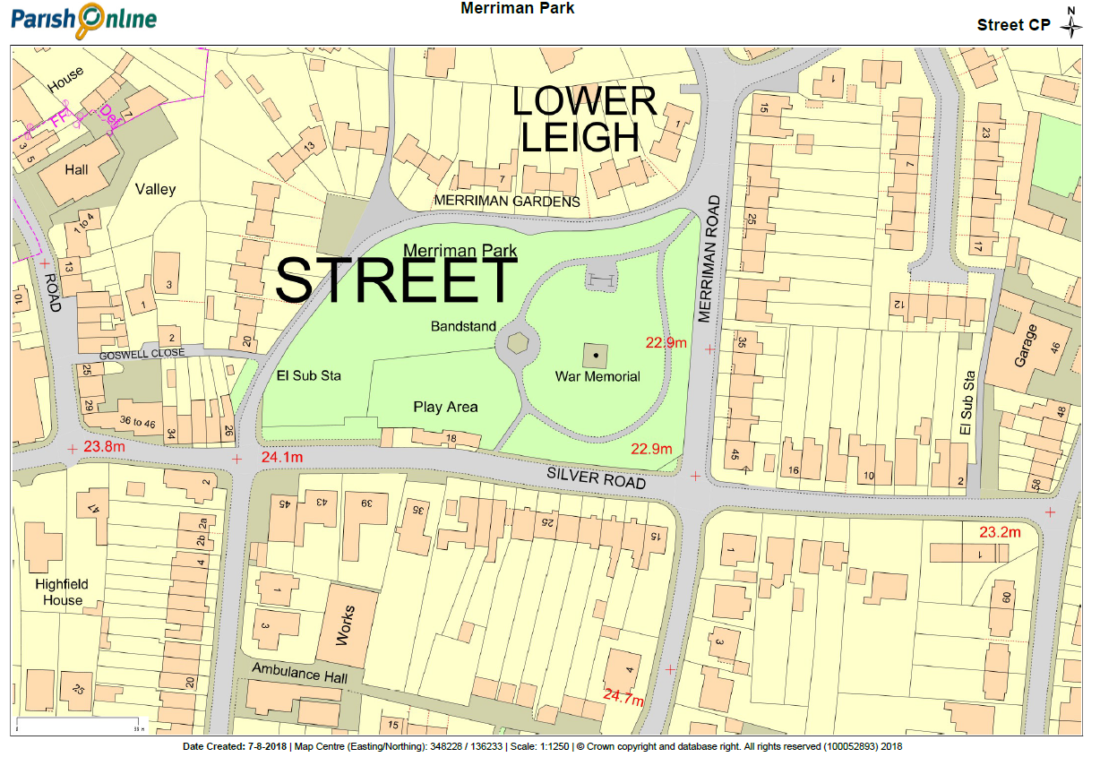

MAP FOR STREET SKATE PARK
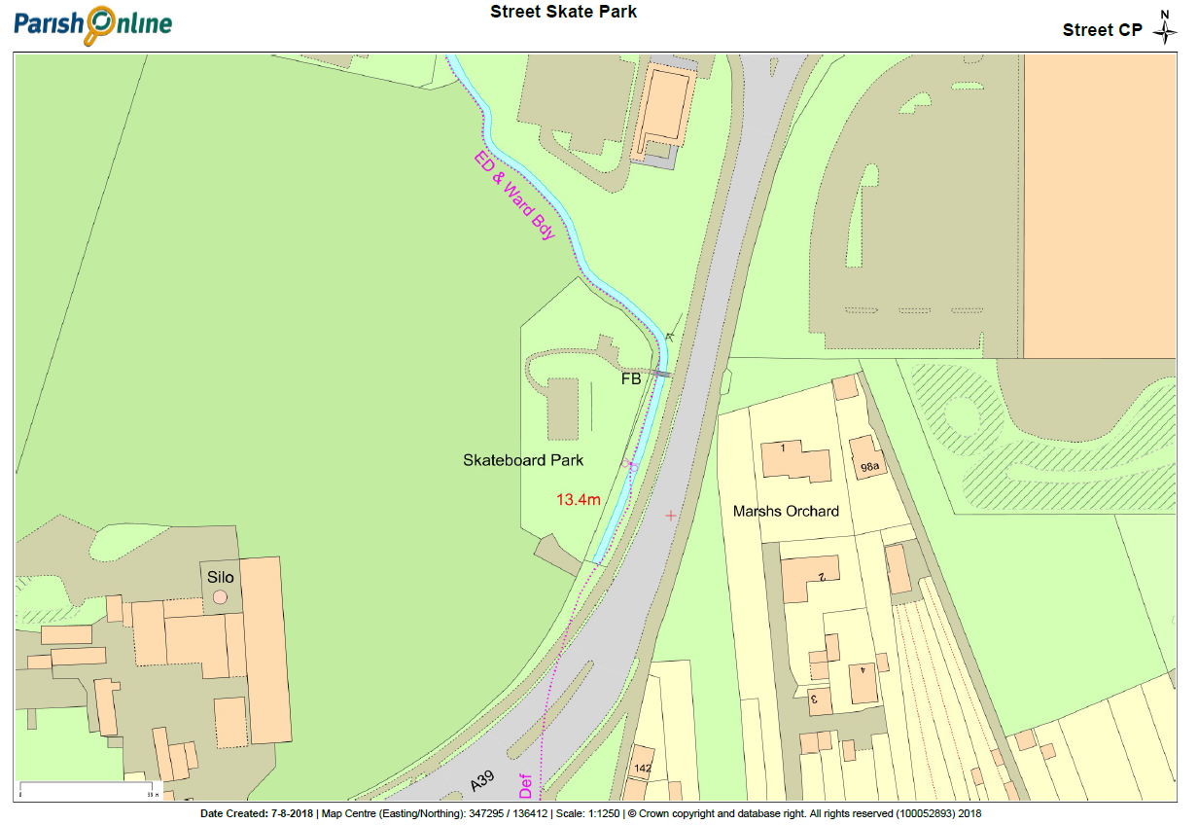

http://www.mapdevelopers.com/area_finder.php
http://homeguides.sfgate.com/keep-hanging-flower-baskets-looking-fresh-21914.html and http://www.hozelock.com/activities/watering-pots-and-hanging-baskets/

