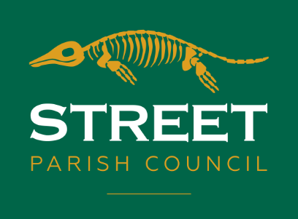
STREET PARISH COUNCIL

Mrs. L.A. Ruff,
Clerk of the Council,
6 Leigh Road,
Street, Somerset
BA16 0HA
TEL: 01458 440588
Email street.parish@street-pc.gov.uk Website www.street-pc.gov.uk

PLEASE NOTE DATE TIME & VENUE

A MEETING OF THE STREET PARISH COUNCIL POLICY AND FINANCE COMMITTEE WILL BE HELD IN ROOM 6 OF THE COMMUNITY CENTRE, LEIGH RD, STREET ON TUESDAY 8TH FEBRUARY 2021 AT 6 PM TO CONSIDER THE GRANT FOR GREENBANK POOL AND AT 7 PM TO CONSIDER GRANTS FOR VULNERABLE PEOPLE AND OTHER BUSINESS

A MEETING OF THE STREET PARISH COUNCIL PLANNING COMMITTEE
WILL BE HELD IN ROOM 6 OF THE COMMUNITY CENTRE, LEIGH RD, STREET ON TUESDAY 15TH FEBRUARY 2022 AT*6:00 PM (PUBLIC QUESTION TIME AT 5.55 PM).

*PLEASE NOTE IF THERE ARE NUMEROUS PLANNING APPLICATIONS THE MEETING WILL COMMENCE AT 6:00 PM (PUBLIC QUESTION TIME AT 5:55 PM) CONFIRMATION OF THE START TIME OF THE PLANNING MEETING CAN BE OBTAINED BY CONTACTING STREET PARISH COUNCIL ON 01458 440588 FROM 10TH FEBRUARY 2022

THIS WILL BE FOLLOWED BY -

THE MEETING OF THE STREET PARISH COUNCIL
WILL BE HELD IN ROOM 6 OF THE COMMUNITY CENTRE, LEIGH RD, STREET ON TUESDAY 15TH FEBRUARY 2022 7:00 PM (PUBLIC QUESTION TIME AT 6.55 PM)

IF ANY MEMBER OF THE PUBLIC OR PRESS WISH TO ASK A QUESTION AT ANY MEETING, THEY SHOULD EMAIL THE PARISH CLERK AT LEAST 24 HRS BEFORE THE MEETING DATE – CONTACT DETAILS ABOVE.

MINUTES ARE PUBLISHED AND AVAILABLE ON THE WEBSITE
https://street-pc.gov.uk/documents/ OR BY CONTACTING THE PARISH CLERK FOR INSPECTION BY ANY ELECTOR IN THE PARISH WITHIN TWO MONTHS OF A MEETING.

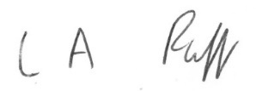

L.A. Ruff
Parish Clerk 31.1.22

