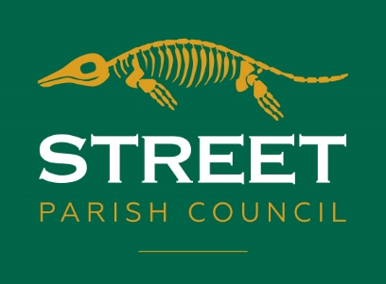
Mrs L. A. Ruff
Clerk of the Council
6 Leigh Road
Street, Somerset
BA16 0HA

T 01458 440 588 E street.parish@street-pc.gov.uk W street-pc.gov.uk

24th February 2022

PRESS RELEASE – GRANT FOR GREENBANK SWIMMING POOL 2022/23

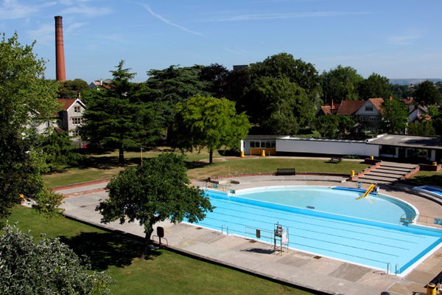

Street Parish Council is very proud to have supported the much-loved Greenbank Pool through the challenging years of Covid-19.

Since 2020, over three financial years, the Council has awarded the Pool grants totalling £80,000. Sadly, due to the Covid restrictions it was not possible to open the facility for the summers of 2020 and 2021 and local residents have really missed being able to enjoy the Pool.

By increasing the grant to Greenbank Pool, the Parish Council has helped ensure the Pool can open again this year, and preparations are now under way to open to the public from Saturday 30th April.

Parish Councillors recently voted for an increased grant for the financial year 2022/23 with conditions attached to the grant including opening dates and hours to ensure the residents of Street have best value for the public funding.

Family season tickets will continue to be offered and for Street residents the price will be reduced, thanks to the Council’s additional support.

Following a public meeting at The Bear, attended by many concerned Street residents, a Friends of Greenbank Pool is being formed to work with the Trustees of Greenbank Pool on plans to make the facility more sustainable.

Chair of the Parish Council Cllr Laura Wolfers said “We all know that the repeated lockdowns, illness and isolation have made life really difficult for many of the residents of Street. As Parish Councillors we are keen to see Greenbank Pool bring people back together in a Covid secure way, improving physical and mental health. We look forward to another summer in the water, on the grass and under the sun at Greenbank Pool.”

The Greenbank Pool Trustees will be making an announcement with details of the opening date, opening times and ticket prices.

Cllr. Laura Wolfers
Chair of Street Parish Council

