Mrs L. A. Ruff
Clerk of the Council
6 Leigh Road
Street, Somerset
BA16 0HA

T 01458 440 588 E street.parish@street-pc.gov.uk W street-pc.gov.uk

10th March 2022 PLEASE NOTE DATE TIME VENUE

Dear Sir/Madam,
You are summoned to attend the meeting of the Street Parish Council which will
be held in Room 6, Crispin Community Centre, Leigh Road, Street on TUESDAY, 15TH MARCH, 2022 for the purpose of transacting the business specified in the following agenda. In accordance with Standing Order 1 t a councillor shall speak only in relation to the motion under discussion and shall not exceed 3 minutes without the consent of the Chair (excluding motions moved under 1 r).

The Annual Parish Meeting will be held before the Council meeting at 6.30 p.m. Public Question Time will commence when this meeting has finished at approximately 6.55 p.m. The Chair will allow each person who has registered with the Clerk to speak for up to 3 minutes on any subject/s and will firstly explain the procedures for the meeting. The Council meeting will commence at approximately 7 p.m. or as soon as Public Question Time is closed by the Chair. Notes of Public Question Time on 15th February 2022 are attached – Page 4. Numbers may be restricted in accordance with Covid guidance at the time. All attendees except children under 16 years may be required to check in by scanning the NHS QR code poster or providing their name and number. Current rules must be adhered to including, if relevant, social distancing, wearing a mask and hand sanitizing. Anyone experiencing Covid symptoms must not attend. It may be necessary to invite people in to the meeting in several sessions to keep within permitted numbers. Alternatively residents are encouraged to make written representations on issues rather than attending in person – contact details above.

In accordance with standing orders 7 c and d, a member with a disclosable pecuniary interest must leave the meeting and be placed in the waiting room during the relevant item of business, unless permitted to remain following the grant of a dispensation. Councillors with an interest in relation to any item of business being transacted at a meeting under Appendix B (Other Interests) or where a matter relates to a financial interest of a friend, relative or close associate, may (i) make representations, (ii) answer questions and (iii) give evidence relating to the business being transacted but must thereafter leave the meeting and be placed in the waiting room, unless permitted to remain following the grant of a dispensation. At a convenient time the Chair will also give this opportunity to any members of the public who have registered to speak with the Clerk prior to the meeting.
hYours faithfully,
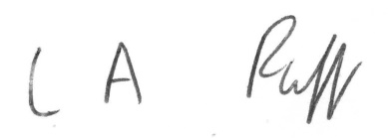j
L.A. Ruff Clerk of the Council
AGENDA
1. APOLOGIES FOR ABSENCE - acceptance of any reasons offered.

2. MINUTES
To approve as a correct record the minutes of the meeting of the Council held on 15th February 2022 (attached) Pages 5 – 12

3. MATTERS ARISING
- 1 -
4. DECLARATIONS OF INTEREST AND DISPENSATIONS
To receive declarations of interest from Councillors on agenda items and to
receive written requests for dispensations for disclosable pecuniary interests
(if any). Clerk to grant any requests for dispensation as appropriate.

5. COMMUNITY POLICE OFFICER

6. PLANNING COMMITTEE
To receive and note minutes of the meeting held on 15th February (attached) Pages 13 – 14

7. CO OPTION TO NORTH WARD (report attached) Pages 15 - 16

8. TASK AND FINISH GROUP – SUPPORT FOR VULNERABLE
To receive a verbal report of the meeting held on 8th March

9. EXCLUSION OF PRESS AND PUBLIC
In accordance with the Public Bodies (Admission to Meetings) Act 1960 amended
by the Openness of Local Government Bodies Regulations 2014, it is probable that
a resolution will be passed at the meeting to exclude the press and public for item
no. 10 as it involves confidential staffing information.

10. STAFF RECRUITMENT
To receive the Confidential report of the Interview Panel (attached for members only)
Page 17

11. CULTURE WORKING GROUP
To receive a verbal report of the meeting on 8th March

12. HIGHWAYS WORKING GROUP
To receive a verbal report of the meeting on 10th March

13. POSITIONING OF TRUESPEED CABINET OUTSIDE MERRIMAN PARK
To receive the report of the Assistant Clerk (attached) Pages 18 - 19

14. BUSINESS ACTION GROUP
Councillor Prior to report on the meeting held on 3rd March

15. REPORT FROM CHAIR

16. PARISH PATH LIAISON OFFICER – County Cllr. Leyshon to give a verbal
report on behalf of PPLO Jake Dalton.

17. MENDIP STRATEGIC TOURISM GROUP – verbal report of meeting on 17th
February

18. CHAIR UPDATES FROM OTHER COMMITTEES/WORKING GROUPS

19. CORRESPONDENCE/MINOR MATTERS (attached) Pages 20 - 21

- 2 -

20. REPORT FROM REPRESENTATIVES ON OUTSIDE BODIES
AND COUNTY AND DISTRICT COUNCILLORS
Questions to be noted for written replies and matters for consideration
referred to the appropriate working group. All reports received have been
emailed to members.

21. ACCOUNTS FOR PAYMENT (schedule of February payments attached for approval and
initialing by Chair) and confidential detailed income and expenditure by account report at 28th
February 2022 including budget variance – emailed to members only with bank reconciliations
and earmarked reserves schedule. Page 22 + Confidential attachment for members only

22. MATTERS FOR REPORT
Consideration of items not on agenda for information only
(a) Report from Clerk
(b) Matters raised by members - TO BE NOTIFIED TO THE CLERK IN
ADVANCE OF MEETING.

___________________

To: Chair and Members of Street Parish Council

- 3 -

NOTES OF PUBLIC QUESTION TIME HELD BEFORE COUNCIL 15.2.22

A resident of Houndwood Close living in an adapted bungalow directly facing the A39 raised issues of noise and disturbance due to speeding vehicles with loud exhausts. Councillor Shearer agreed to contact the person to discuss what action could be taken.

The owner of a travelling fair and Councillor Napper spoke about the advantages of having a fair in Street. The other Mendip towns had an annual fair. It was agreed that the person would send a full proposal to the Clerk on how this could work, possible dates and where it might be held such as a car park for the Council to consider.

The manager of the Community Centre asked if she could make her presentation, which there had not been time to consider at the Policy and Finance Committee meeting on 8th February, before decisions were made on grant funding being considered at that meeting. Members assured her that she would be given this opportunity.

- 4 -

STREET PARISH COUNCIL

A meeting of the Council held in Room 6, Crispin Community Centre on
15th February 2022 at 7:12 p.m.

PRESENT: Councillor L. Wolfers (Chair of Council)
Councillors: P. Birch, R. Boyce, S Carswell, D. Drew,
M. Daniells D. Goater J. Howard, D. Knibbs,
T.W.E. Napper, H. Shearer, N. Smith, A. Sparkes

IN ATTENDANCE: L. Ruff – Clerk/RFO
J. Marshfield – Assistant Clerk
County and District Councillor L. Leyshon

APOLOGIES Councillors: A. Leafe and A. Prior – another
engagement – reasons accepted.

216. MINUTES

The minutes of the meeting held on 18th January 2022 which had been circulated were approved as a correct record and signed by the Chair with the following amendments -
Minute No. 198 – 5th line to read ‘Reynolds Way’
Minute No. 200 – resolution A to read ‘town and village’
Minute No. 206 – resolution B to read ‘Cllr. Shearer had asked Ian Black’.

217. MATTERS ARISING

The Clerk reported that the artist would be sending the exact design for the
Library Garden 4th mural for final approval and that the fingerposts would be
refurbished soon.

218. DECLARATIONS OF INTEREST AND DISPENSATIONS

In accordance with the Code of Conduct Councillors Carswell, Napper and Shearer declared an other interest under Appendix B in any matters relating to the District Council and stated that they would keep an open mind when considering issues at either District or Parish level.

Councillor Napper declared an other interest under Appendix B in any
matters relating to the County Council and stated that he would keep an open mind when considering issues at County or Parish level.

Councillor Howard declared an other interest under Appendix B in any
matters relating to the Crispin Hall as she was a trustee.

- 5 -
Councillor Drew declared an interest in any matters relating to the Street Library as she was a member of the Friends of Street Library.

Councillor Wolfers declared a disclosable pecuniary interest in any
matters relating to Street Chamber of Commerce as she worked freelance for it.

219. COMMUNITY POLICE OFFICER

There was no Police representative at the meeting. There had been reports of
several attacks around Street recently but no one had details. It was agreed to
make the Police aware that it appeared that a certain insurance company would not
insure properties in the BA16 area. Councillors Smith and Sparkes needed a third
person to set up a community speed watch.

Councillor Shearer would take action in regard to the problem of road noise which
had been raised during public question time.

Councillor Napper suggested that trees be planted on the side of the bypass where
the caravan and horses had just been removed from. It was agreed that the
Assistant Clerk would send a plan of the area to Councillor Shearer so that she could
see if the District Council could provide trees. Councillors Napper and Smith would
assist as appropriate.

220. PLANNING COMMITTEE

The minutes of the Committee meeting on 18th January, 2022 were submitted as
circulated.

RESOLVED

that the report be noted.

221. POLICY AND FINANCE COMMITTEE

The minutes of the meeting on 8th February 2022 were submitted as circulated and
appear as Annex A in the Minute Book.

- 6 -

An update from the Salvation Army and YMCA had also been circulated. Councillor
Shearer felt that the recommendations in regard to the vulnerable should be looked
at in the wider round to find a more comprehensive way forward. In December it
had been agreed to ask all the schools and College what they needed for PFSA
support. This had been done but there had been a mixed response. A consensus
needed to be reached between all of the schools and the College on what they
wanted and other groups supporting the vulnerable also needed to be considered.

The decision on PFSA funding of May 2019 had been for all schools and the College
and subject to an agreement with the County Council to ringfence funding. The
decision was clearly not enacted and no agreement had been entered into. 2 ½ years
had passed and things had changed and it was appropriate to revisit the matter. In
November 2019 it had been reported that the draft agreement had not been received
and the County Council would be considering PFSA provision as a whole early in 2020
so the matter had been put on hold. This and the use of any unspent funds from the
allocation in 2019/20 towards the cost of altering the Parish Rooms was agreed by
Council on 19th November 2019.

County Councillor Leyshon now had contacts at the County Council who would be
able to assist with enquiries about PFSA funding, an agreement etc. There was a
need to get the schools together and gain real clarity on the issue.

RESOLVED

A. that the bi annual risk assessment, annual investment strategy, receipts and
payments October to December 2021 and periodic reports and inspections be
approved

B. that Glastonbury Town Council be asked for details of what they had done
regarding assistance for vulnerable people

C. that the annual grant of £10,000 be made in 2022/23 to the YMCA for the
delivery of 2 sessions a week at the Youth Club

D. that a Task and Finish Group be created to look at vulnerable people and
deprivation in Street and undertake to meet within 1 month – a standard letter to
be sent to all the schools and the College asking if they need to be supported and
to what degree and asking them to come to a meeting or give their concerns and
what they needed regarding PFSA funding – the terms of reference for the group
to be to look at what schools said on PFSA funding and also to look at all the
requirements of organisations supporting the vulnerable such as the YMCA and
Community Centre together – Councillors Daniells, Drew, Carswell, Howard,
Shearer, Smith, Wolfers and County and District Councillor Leyshon to serve on
the Group

- 7 -

E. that legal advice be taken for the Council and the Clerk in respect of the
situation regarding funding of PFSAs

F. that the recommendation on the grant for Greenbank Swimming Pool be
agreed except that there should not be a joint press release from the Council
and the Trustees – the press release from the Council to state that it has given
support to the Pool through grants totalling £80,000 over the 3 years from
2020/21.

222. LOCAL GOVERNMENT REVIEW

The Chair had circulated notes of the meeting with Glastonbury Town Council
on 3rd February. The Town Council had a suitable site for a pump track opposite
the Red Brick Building but there was no parking, it was on the side of a main road
and might be considered too small. There was a good bus service. There had also
been discussion on transportation between Street and Glastonbury. There was a
mental health hub at the rear of St. Dunstan House and it was hoped to have pop
clinics twice a week at the Community Centre.

Councillor Carswell reported that the Glastonbury Town Deal involved funding
of £23.6 million for 12 projects with a lot based around the Red Brick Building
which would therefore have an impact on Street. There would be an event
about this on 25th February in the Town Hall. The Chair reported that there would
also be a meeting for businesses in the Town Hall on 3rd March.

223. CULTURE WORKING GROUP

The notes of the meeting on 19th January had been circulated.

RESOLVED

that the report be agreed except that the Council staff would still prepare the
event management plan and book the marquee etc. for the Fun Day.

224. EXCLUSION OF PRESS AND PUBLIC

RESOLVED

that in accordance with the Public Bodies (Admission to Meetings) Act 1960 as
amended by the Openness of Local Government Bodies Regulations 2014, the press
and public be excluded from the meeting for the following items as they involved
confidential staffing, legal and quotation information.

- 8 -

225. LIBRARY WORKING GROUP AND STREET CLP

The confidential notes of the meeting on 9th February with R. Clark of the Library
Trust had been circulated to members only. It was agreed to ensure that the
grant for Greenbank Pool was not used for the Library as requested by Councillor
Napper.

RESOLVED

that the notes be agreed.

226. CHRISTMAS ILLUMINATIONS 2022

The confidential report of the Assistant Clerk had been circulated to members
only.

RESOLVED

that a 1 year extension with Blachere Illuminations be agreed for the lights in the
High Street and at the Parish Rooms for 2022 and consideration be given to
buying a storage unit.

227. QUOTES TO REPAIR SKATE PARK

The confidential report of the Clerk had been circulated to members only.

RESOLVED

A. that D.B. Gibbons be engaged to replace the damaged section of concrete at
the Skate Park for £2,480 + VAT and SLH Services be instructed to reduce the
height of the hedge as much as possible prior to 1st March

B. that the Police be asked if they can provide temporary CCTV for the area and
McDonalds be asked to monitor the area using their security personnel

C. that the owners of the Business Park be asked to install additional lights
when the residential home is built by the Skate Park.

228. POST OF DEPUTY CLERK/RFO

The confidential report of the Clerk had been circulated to members only.

RESOLVED

that the Interview Panel be given delegated authority to agree any flexible/home
working arrangements with the selected candidate.

- 9 -

229. MAINTENANCE OF WOODS BATCH

The confidential report of the Clerk had been circulated to members only.

RESOLVED

that the interest in taking responsibility for Woods Batch be stopped as it would
not be cost efficient for the people of Street.

230. BUSINESS ACTION GROUP

It was noted that Councillor Prior would organise the next meeting on 3rd
March.

231. REPORT FROM CHAIR

The Chair thanked former Councillor Mogg for all of his services and noted that
a contribution had been made to the Salvation Army on his behalf. A card would
be sent to him signed by staff and members.

232. PARISH PATH LIAISON OFFICER

County and District Councillor Leyshon had not seen the PPLO recently.

233. MENDIP STRATEGIC TOURISM GROUP

No report was made. The January meeting had been attended by the ACPO.

234. CORRESPONDENCE/MINOR MATTERS

The Clerk submitted a report which had been circulated.

1. Literary Festival

RESOLVED

that the arrangements and use of the Parish Rooms be agreed.

2. Library Working Group and Greenbank Pool Management Committee

RESOLVED

that the report be noted.

- 10 -

3. Vacancy in the North Ward

RESOLVED

that notices be displayed inviting suitable candidates to apply to be considered
for co-option at the meeting on 15th March and 2 or 3 meet and greet sessions be
organised for potential candidates ahead of the elections by a few members.

4. Street Visitor Leaflet

RESOLVED

A. that the leaflet be agreed at no cost to the Council with the new logo and
any alterations needed

B. that £500 Mendip Tourism grant funding left when the fingerposts had been
refurbished be used to replace the bench removed at Marshalls Elm.

5. CCLA Public Sector Deposit Fund

RESOLVED

that the report be noted.

235. REPORT FROM REPRESENTATIVES ON OUTSIDE BODIES AND
COUNTY AND DISTRICT COUNCILLORS

Councillor Napper raised the need to cut back a hedge at Stone Hill as a lady had
fallen off of the pavement trying to get past it and it was agreed to write to Area
Highways. He stated that he no longer wished to serve on the Victoria Field
Charity Committee.

Councillor Shearer reported that if still available cherry blossom trees would be
planted at Woods Batch by the District Council to celebrate the Platinum Jubilee.

Councillor Carswell reported that the event being held at The Loft by the
Merriman Park Community Group to raise funds was now sold out.

236. ACCOUNTS FOR PAYMENT

The latest bank reconciliations for all accounts at 31st January 2022 had been
prepared successfully and sent to all members with the monthly income and
expenditure by account report, the final report of receipts and payments for
January, schedule of earmarked reserves and a consolidated summary.

- 11 -

RESOLVED

that the report and schedule of payments as circulated be approved and initialled
by the Chair and the income and expenditure by account report at 31st January
2022 be noted and the schedule of receipts and payments for January be attached
as Annex B to the minutes in the Minute Book in order to publish payments of
£500 or more.

237. MATTERS FOR REPORT

The Clerk reported that Truespeed had recently placed a large cabinet and a pole
on land owned by the Council just outside Merriman Park and the permission
gained for this was being investigated as the Council had not been notified and it
would have an impact on any potential future development of the area.

Councillor Smith raised the fact that the lights by the steps leading from Clarks
Village play area to the High Street had not worked for some time and it was
agreed to contact C. and J. Clark about this.

The meeting ended at 9.20 p.m.

Councillor Birch left at 8.30 p.m.

- 12 -

STREET PARISH COUNCIL

Meeting of the Planning Committee held in Room 6 of the Community Centre, Leigh Road, Street on 15th February at 6:00 pm

PRESENT: Councillors D Knibbs- Chair, T Napper, P Birch.

APOLOGIES: Councillors A Leafe, L Wolfers

IN ATTENDANCE: J Marshfield – Assistant Clerk

30. MINUTES

The minutes of the meeting held on 18th January 2022 which had been
circulated, were approved as a correct record, and signed by the Chair.

31. DECLARATIONS OF INTEREST AND DISPENSATIONS

None received.

32. PLANNING APPLICATIONS

The Assistant Clerk & Projects Officer submitted a report which had been circulated.

RESOLVED

2022/0034/HSE Erection of a garage and workshop at 9 Orchard Road Street –
Approval

2022/0033/HSE Erection of a single storey rear extension at 9 Orchard Road Street –
Approval

2021/2804/FUL Erection of 3no. single storey extensions to Ivythorn Day House at
Millfield School Butleigh Road Street - Approval

2022/0054/HSE Erection of single storey rear/side extension & fenestration changes
at 38 Grange Avenue Street - Approval

2022/0065/HSE Single Storey Rear Extension and Alterations at 3 Seeley Crescent
Street - Approval

2021/2751/FUL Installation of 2No rapid electric vehicle charging stations in car park
at Mcdonalds Restaurants Ltd Gravenchon Way Street - Approval

- 13 -

2021/2900/HSE Single storey rear and side extensions and 2no. first floor extensions
at 11 Housman Road Street - Approval

2021/2753/ADV 1 x self-illuminating fascia sign, 1x projection sign at Unit 9 Clarks
Village Farm Road Street - Approval

2022/0104/HSE Erection of a single storey rear extension, alterations to main roof at
51 Somerton Road Street - Approval

2022/0129/HSE Part demolish existing garage and erection of single storey front/rear
extensions and associated parking at 17 Blenheim Road Street - Approval

2022/0148/HSE Erection of a single storey rear extension at 10 Oakfield Road Street -
Approval - obscure glass to be used for windows overlooking neighbouring properties

2022/0154/HSE Erection of a single storey rear extension at 3 Wilton Close Street –
Approval

2022/0182/HSE Single storey extension to rear at 22 Brookleigh Street - Approval

2022/0181/ADV Installation of a steel frame structure displaying individual business
signs at Phase 6B Street Business Park Gravenchon Way Street - Approval

2022/0200/HSE Loft conversion with rear dormer and single storey rear extension at 4 Cranhill Road Street - Approval

NOTE - 0 new units approved – 1 since May 2021.

The meeting ended at 6:25 pm.

- 14 -

AGENDA ITEM NO: 7

To: Council
From: Clerk
Subject: Co-Option to North Ward

The Chair to call for nominations to fill the vacant seat in the North Ward by co-option to the Council (procedure attached). The period of the vacancy has less than 6 months to run but the Council on 15th February agreed to co opt to fill it. L. Mogg resigned from the Council on 18th January and a poll was not claimed in time. Public notices have been displayed inviting suitably qualified people to apply to the Council for co option on the website and Facebook. The candidates who have stated that they wish to be considered for the vacant seats are as follows and their forms are attached for members -

Peter Goater

All persons have certified in writing that they meet the criteria for eligibility set out in section 79 of the Local Government Act 1972 to be a member of the Council and are not disqualified pursuant to section 80 of the Act. To qualify as a candidate persons must live, have a business or work in Street or within 4.8 km for at least 1 year or be on the electoral role and be over 18 years of age.

Any candidate who is to be considered for co option until the end of the current term in May 2022 must be proposed and seconded at the meeting. Voting will be carried out in public by show of hands and candidates will be invited to go in to a waiting room for this.

The successful candidate will be invited to join committees and working groups when they have served on the Council for 3 months.

L.A. Ruff
Clerk
15.03.22

- 15 -

A successful candidate must have received an absolute majority vote of those present and voting i.e. over half of the votes cast. If this is not the case voting continues until someone does have an absolute majority of votes cast. This is done by striking off the candidate with the least number of votes and the remainder must then be put to the vote again.

This will mostly be a satisfactory procedure but if several candidates have obtained the same number of least votes and the aggregate of the others is less than a normal quorum eg. 3:2:2:2:2, it may be thought wise not to strike off all those with the least votes together but, if negotiations for withdrawals fail, to strike them off one by one, in an order determined by vote.

If there is an equal number of votes the Chair can use their casting vote to decide on a candidate. The new co-opted member can if present, sign the declaration of acceptance of office and then take part in the meeting but as it will be a remote meeting and, if not present can sign before or at the next ordinary meeting of the Council.

- 16 -

AGENDA ITEM NO: 13

To: Councillors

From: Assistant Clerk

Subject: Positioning of Truespeed Fibre Cabinet outside of Merriman Park.

Truespeed have positioned a Truespeed Fibre Cabinet on SPC’ land outside of Merriman Park (opposite the Park Fish & Chip shop)

Truespeed were contacted to enquire who had given permission for the cabinet to be placed in this position. The permission was granted by SCC.

I contacted SCC to inform them that SPC had not given permission for the cabinet to be placed in this position. SCC responded as follows: -
I can confirm that it is the responsibility of the Statutory Undertaker, Truespeed, in this instance, to ensure they have obtained the necessary permissions to work on private land. There is no mechanism in place for notifying Parish Councils of these works unless they require a road closure – which in this case, they did not. If the install did require a road closure, then Parish Council would have been informed via the normal procedure.
If apparatus has been installed on private land, without permission being sought, then this would need to be a discussion between the utility that owns the apparatus and the private landowner.

Spencer Hobbs at Truespeed was contacted and Tom Booth, Truespeed’s Network Access Officer & Regional Team Lead, replied informing SPC that –
HM Land Registry records are our terms of reference for researching and identifying private property ownership and making decisions with whom to seek wayleave agreements with.
With reference below to HM Land Registry MapSearch snapshot the ground where we have sited the cabinet is unregistered (circled in black). Therefore, we sought and obtained permission from Somerset County Council’s Streetworks department.

- 18 -
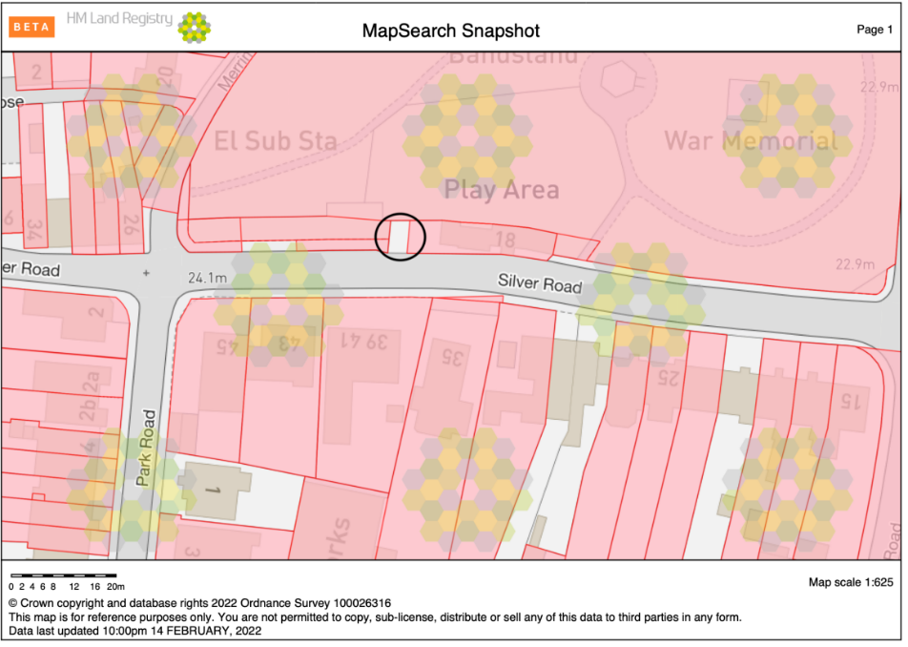

This information has now been verified and Truespeed are correct - the Land Registry Title Plan of Merriman Park below shows that the area where the Truespeed Fibre Cabinet (marked with red dot) has been placed on unregistered land.
Conclusion - Truespeed have followed the correct procedure.
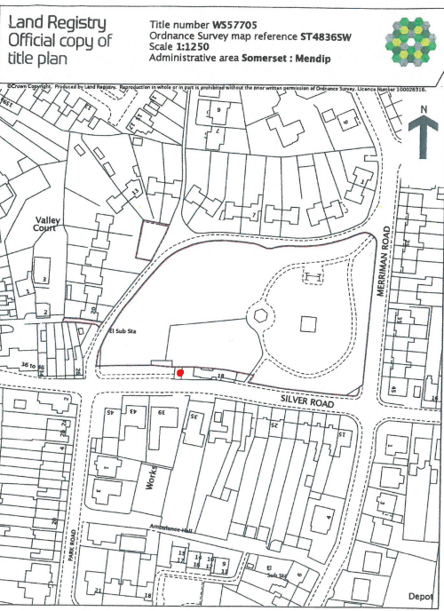

Jenny Marshfield
Assistant Clerk

- 19 -

AGENDA ITEM NO: 19

To: Council
From: Clerk
Subject: Correspondence/Minor Issues

1. Date of Policy and Finance and Planning Committee in May

To agree that the Policy and Finance Committee will meet at 6 p.m. on Tuesday 3rd May and not on 10th May as this will be after the Elections. To also agree that the Planning Committee will meet at 7 p.m. on 3rd May. Monday 2nd May is a Bank Holiday. Alternatively the meetings could take place on 4th May but this is the evening before the elections. I will not have end of year accounts documents ready before 3rd May.

The elections will be held on 5th May with new councillors taking up office on 10th May and the annual Council meeting being held on 17th May when membership of committees etc. will be agreed.

2. Application for Premises Licence – Street Inn, 1 – 3 Somerton Road, Street
Licensing Act 2003

EI Group Ltd. have submitted the above application for live and recorded music, provision of late night refreshment and supply of alcohol. Outdoor events are limited to 4 per year and must cease at 21.00 hrs. New Years Eve from the end of permitted hours on New Years Eve to the start of permitted hours on New Years Day. Proposed shadow conditions have been circulated to members and include that musical entertainment shall cease at 23.00 hrs Sunday to Thursday and 00.00 hrs Friday and Saturday to protect the night time noise environment of the area.

3. Grant Application – Victoria Field Social Club – Queen’s Jubilee Event

The Victoria Club have applied for £500 towards costs of £800 to hold a Jubilee event on Saturday 2nd July for the community.

4. Application to Hold a Fun Fair in May

Further to addressing the Council on 15th February Edward Stokes Funfairs has applied to hold a small family friendly funfair in either Merriman Park or Cranhill Road Car Park from Monday 16th to Monday 23rd May 2022.
Arrive on site 10 am on 16th
Set up and testing 9 am to 8 pm 17th and 18th
Dismantle and leave by 6 pm on 23rd
Operating Days
19th and 20th from 5 pm to 9 pm
21st 1 pm to 9 pm
22nd 1 pm to 6 pm

Mendip DC has already informed us that it cannot consider relocating the market until 2023/24 at the earliest due to the work involved in the local government review. It therefore seems very unlikely that they could consider this matter this year. I am also extremely busy and under huge pressure with my only remaining assistant leaving at the end of April and no replacement in post as yet. Residents should also be consulted on the proposal so an event in 2023 would be best.

- 20 -

5. 5G Mendip Questions on Radiofrequency Radiation Regulation

Fromforsafetech have asked local councils to co-sign questions to Mendip about the regulations of exposure to Radiofrequency Radiation. Full details have been circulated to members.

L.A. Ruff
Clerk/RFO
15.03.22

- 21 -

AGENDA ITEM NO: 21

To: Council
From: Clerk
Subject: Accounts for Payment

The latest bank reconciliations for all accounts at 28st February 2022 have been prepared successfully and sent to all members with the monthly income and expenditure by account report and earmarked reserves. Each reconciliation and original bank statement will be signed by Councillor Prior as part of the quarterly check of accounts and Councillors Carswell and Daniells are doing an online check.

Receipts and, payments to be authorised, for February are detailed on the attached pages and will appear as an annex to the minutes.

L.A. Ruff
Clerk
15.03.22

Approved by Council on 15th March 2022 and initialled by Chair:

- 24 -

