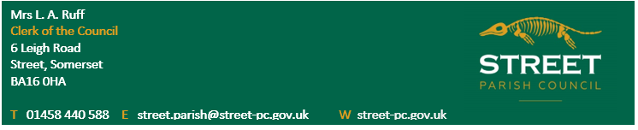
NOTICE OF VACANCIES IN THE OFFICE OF
PARISH COUNCILLOR
North, South and West Wards of the
Parish of Street
NOTICE IS HEREBY GIVEN that 8 Parish Councillors have been elected without a contest and there are 3 vacancies in the North Ward, 4 vacancies in the South Ward and 1 vacancy in the West Ward
Suitably qualified persons are invited to submit their names and a brief personal summary to the Parish Clerk, Mrs. L.A. Ruff – details above for consideration for co-option to the Council at the Annual meeting to be held from 7 p.m. on Tuesday 17th May, 2022 in Room 6, Crispin Community Centre, Leigh Road, Street.
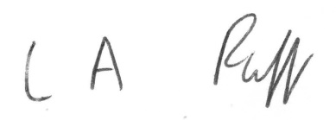
L.A. Ruff Clerk to Street Parish Council 13th April, 2022

