Mrs L. A. Ruff
Clerk of the Council
6 Leigh Road
Street, Somerset
BA16 0HA

T 01458 440 588 E street.parish@street-pc.gov.uk W street-pc.gov.uk

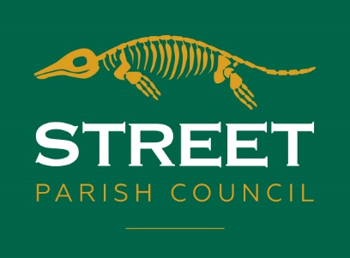

NOTICE OF VACANCY IN THE OFFICE OF PARISH COUNCILLOR

NORTH WARD OF THE PARISH OF STREET

NOTICE IS HEREBY GIVEN that 8 Parish Councillors have been elected without a contest and 7 Councillors were co-opted at the Annual meeting of the Council on 17th May 2022. There is 1 vacancy in the North Ward.

Suitably qualified persons are invited to submit their names and to complete the co-option form and return it to the Parish Clerk – Mrs. L.A. Ruff – details above for consideration for co-option to the Council at the meeting to be held from 7 p.m. on Tuesday 21st June 2022 in Room 6, Crispin Community Centre, Leigh Road, Street.

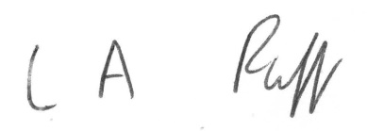

L.A. Ruff
Clerk to Street Parish Council
26th May 2022

